Azure DevOps Pipelines CI CD Tutorial

Continuous integration and deployment of a Xamarin.Forms App

Introduction

In this tutorial, I will be using a fully featured continuous integration (CI) and continuous delivery (CD) service called Azure Pipelines to automate the build, testing, and deployment of a Xamarin.Forms mobile app to the Visual Studio App Center.

What’s covered in this tutorial

* Setting up an Azure Repos Project
* Creating a Xamarin.Forms App
* Setting up a build pipeline for CI
* Setting up a release pipeline for CD

Prerequisites

* A free Azure DevOps account (https://dev.azure.com)
* Visual Studio 2017 IDE for Windows (<https://visualstudio.microsoft.com/vs/older-downloads/>)
  + Make sure Xamarin is selected during IDE installation
* A free App Center account (https://appcenter.ms/)

Creating a blank project in Azure repos

Navigate to your Azure account with the following url: [https://dev.azure.com/{username}](https://dev.azure.com/%7busername%7d) ; {username} should be replaced with an appropriate value associated with the account.

Create a new project as shown below

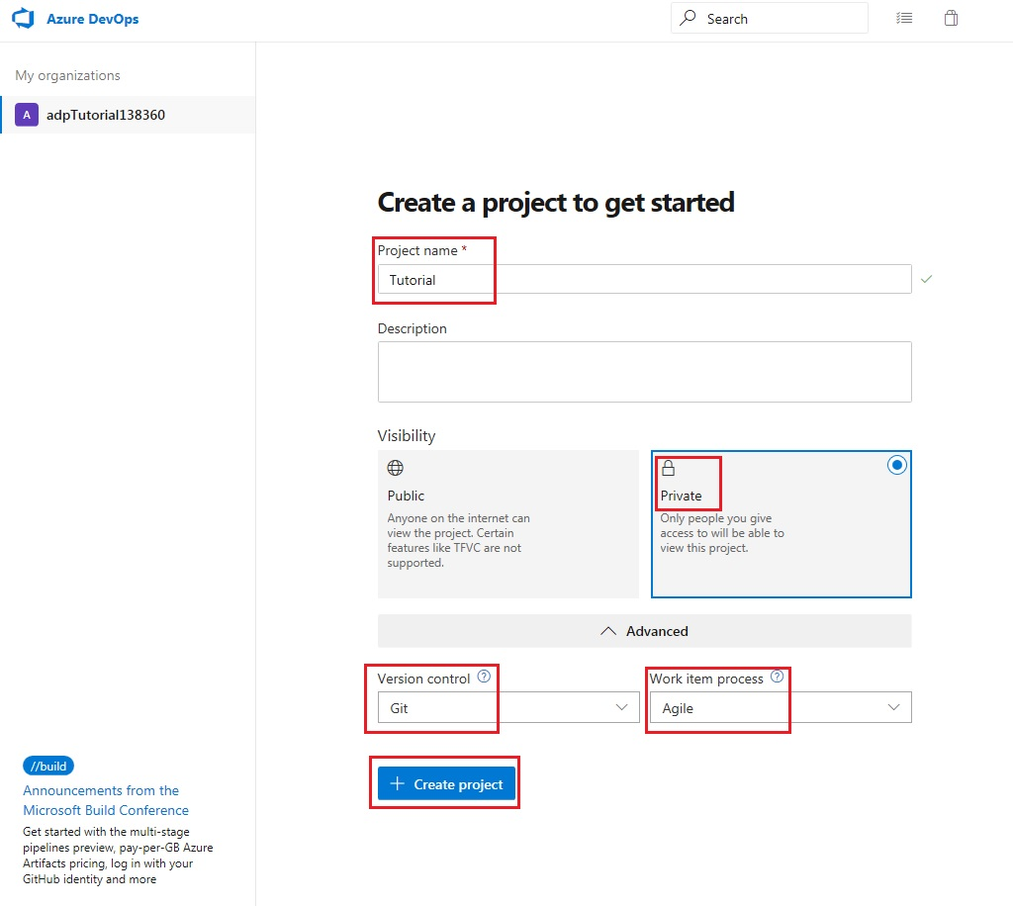

Click on the code icon of the newly created project

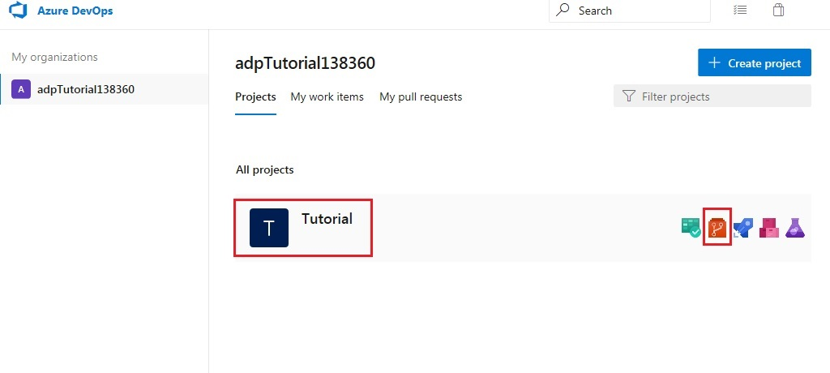

This takes you to the newly created project page with the following greeting message: “Tutorial is empty. Add some code!”. Before adding some code, the repository will need to be cloned in Visual Studio.

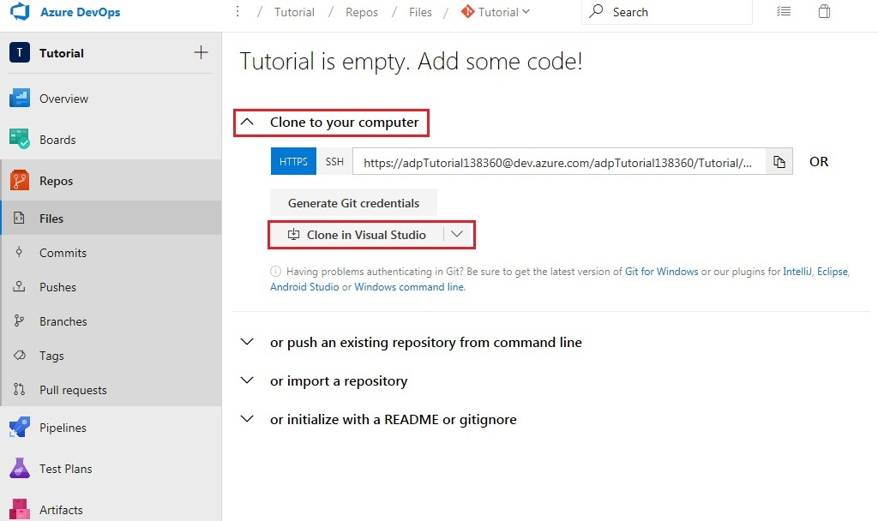

You will be redirected to a new tab with a popup message. Click ‘Allow’ when prompted by your web browser. This will cause Visual Studio to be launched.

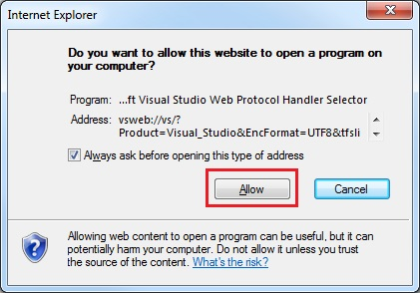

Select an appropriate location and clone the repository to your computer.

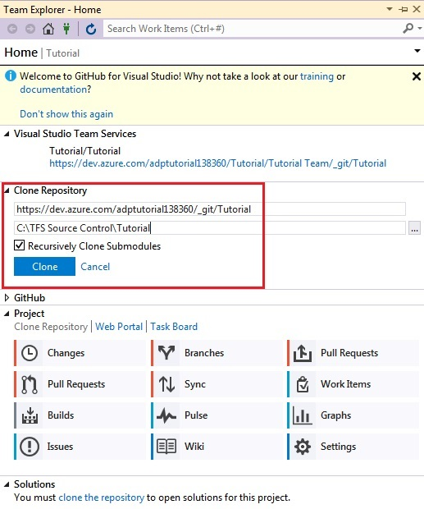

Creating a Xamarin.forms app in vs2017

While in Visual Studio, create a new project as follows

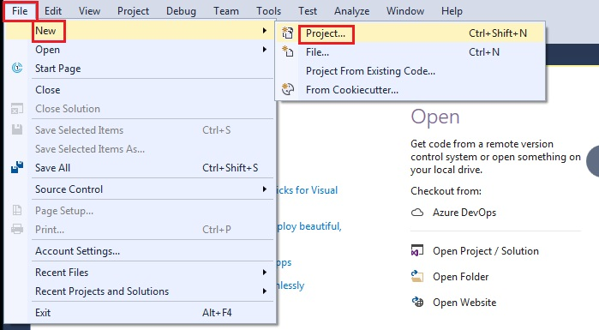

Make sure the location selected matches the folder where your repository was cloned

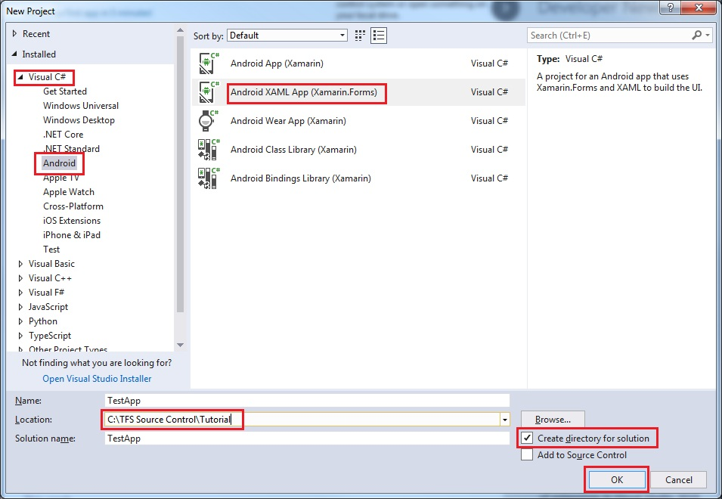

Open the Solution Explorer window in Visual Studio to build the solution. Set build platform, configuration and start-up project as shown below.

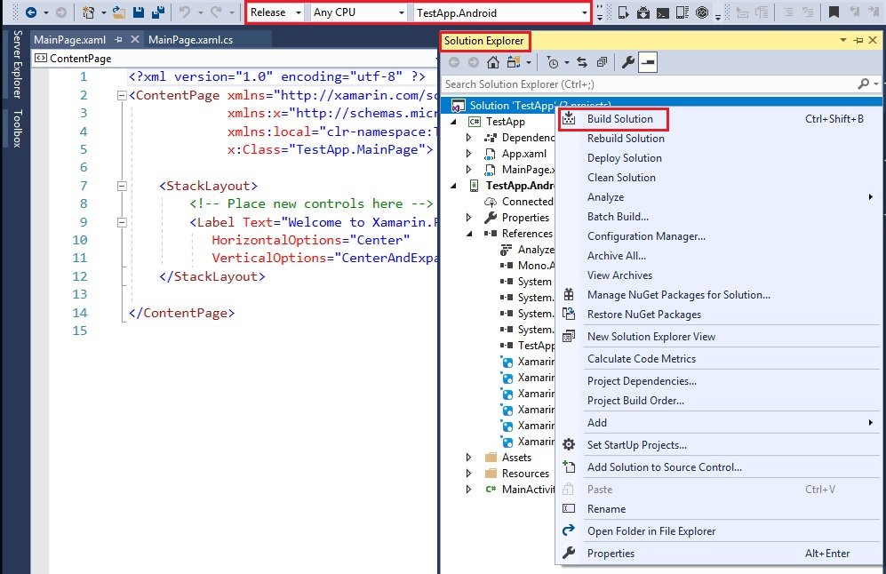

After a few minutes, the Output window in Visual Studio should indicate that the build succeeded.

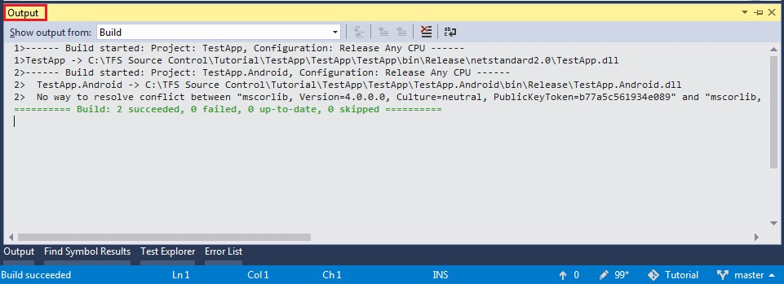

Now, open the Team Explorer window in Visual Studio. Click on the ‘Changes’ button under the ‘Home’ tab.

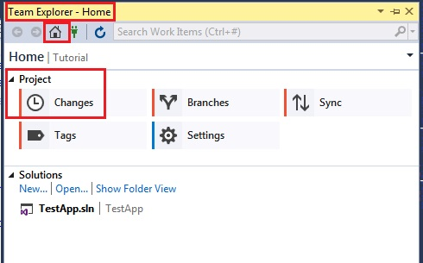

Do not be shocked at the number of changes. As Most of these can be ignored.

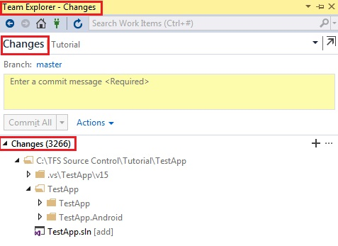

Ignore the following items:

* .vs\TestApp\v15
* TestApp\TestApp\bin\Release\netstandard2.0
* TestApp\TestApp\obj
* TestApp\TestApp.Android\bin\Release
* TestApp\TestApp.Android\obj

This should lead to a considerable decrease in the number of changes as well as an update of the ‘.gitignore’ file which will appear under ‘Staged Changes’.

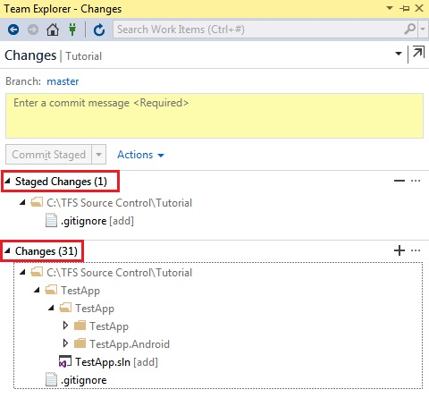

Stage the remaining changes

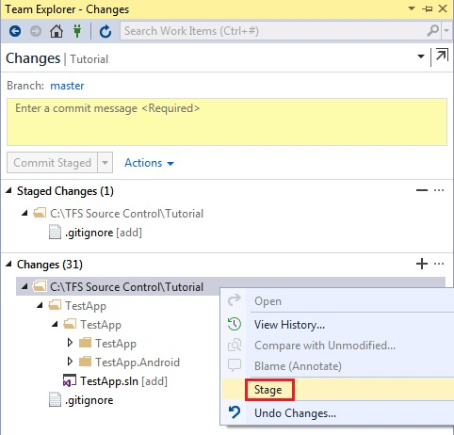

Enter an appropriate comment and commit the changes

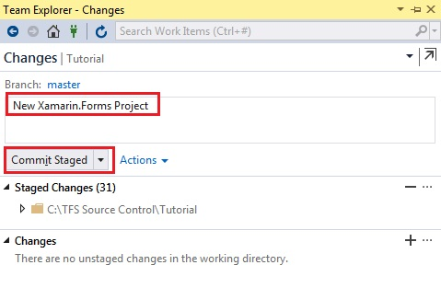

Click on the ‘Sync’ button under the ‘Home’ tab of the Team Explorer window in Visual Studio and ‘Push’ your commit to the server.

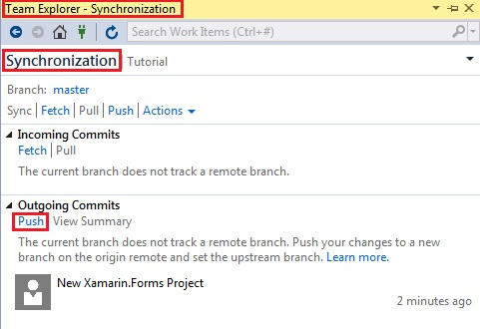

Return to your browser and refresh the tab or access your repository using the following link: [https://dev.azure.com/{orgname}/_git/{projectname}](https://dev.azure.com/%7borgname%7d/_git/%7bprojectname%7d); where {orgname} is your Azure account name and {projectname} is ‘Tutorial’ or whatever name you chose for the project.

Instead of the previous greeting message, you should now be presented with your TestApp project.

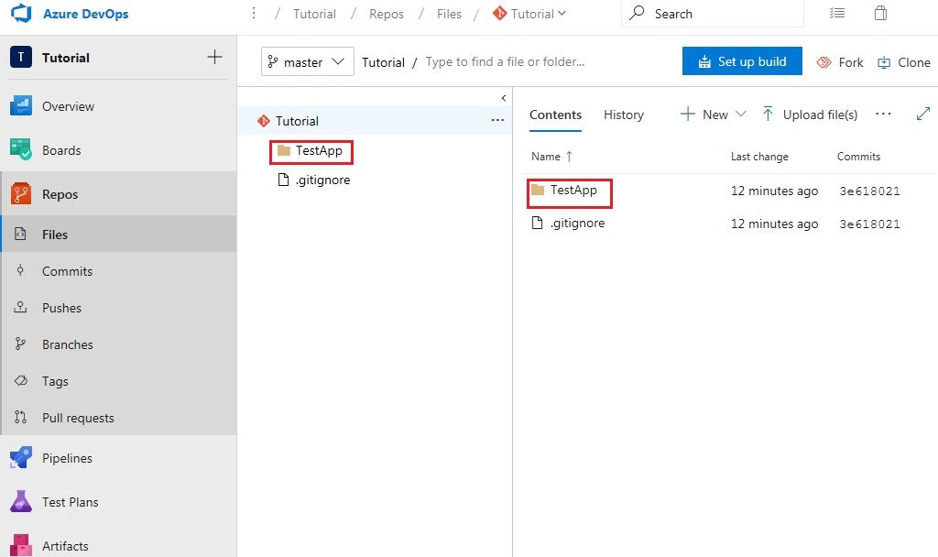

Now that the project has been successfully added to your Azure repository, open a new tab and navigate to your app Center dashboard using the following link: https://appcenter.ms/apps

Once you’ve signed in, select the ‘Add new’ button to create a new app as shown below. Make sure that the app name matches the name of the Xamarin.Forms project created in Visual Studio.

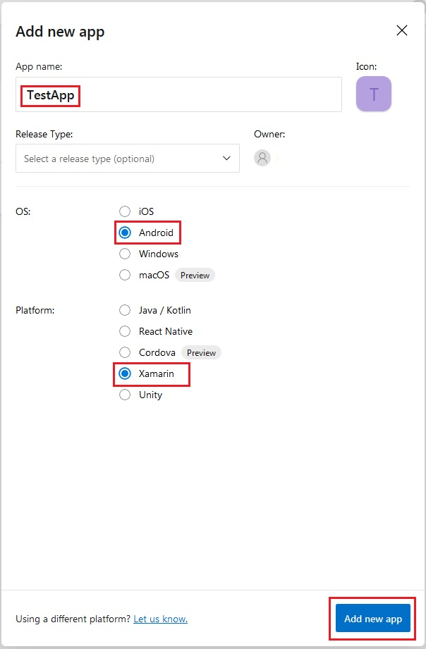

Now return to your Azure Repository to setup the build pipeline

Setting up the build pipeline

Navigate to the build pipeline

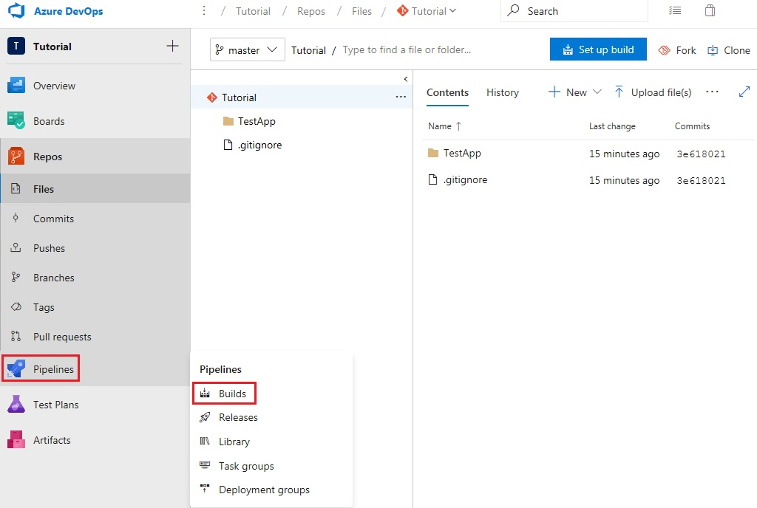

Click ‘New pipeline’

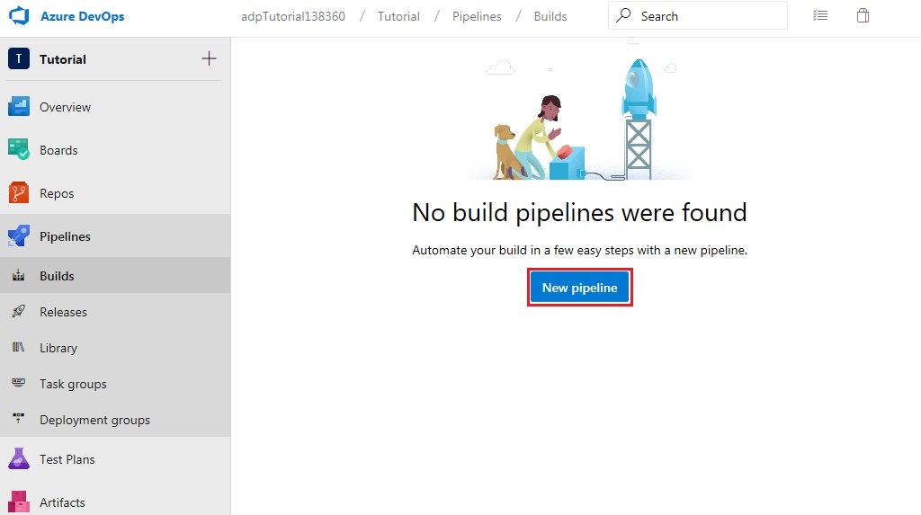

Use the classic editor

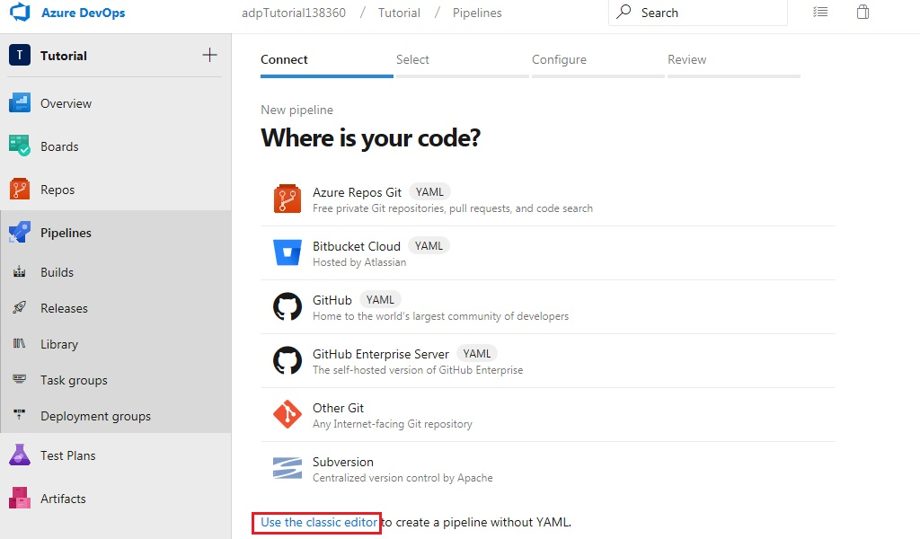

Continue with details set as shown below

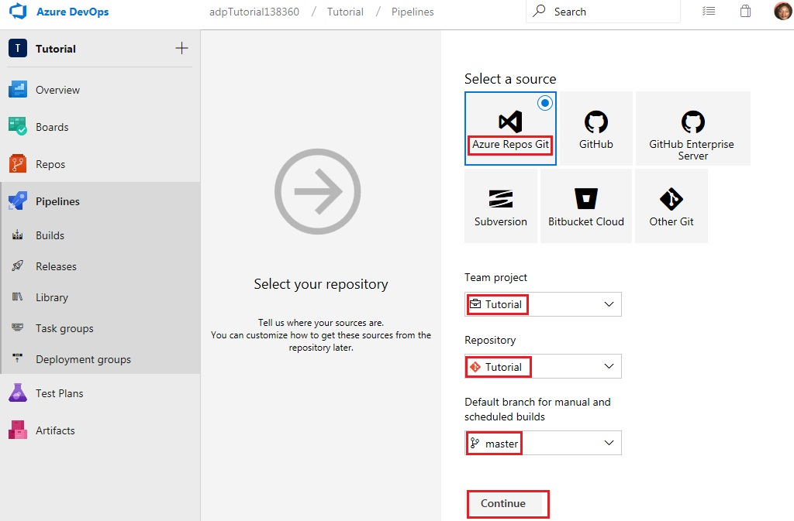

Start with an empty job

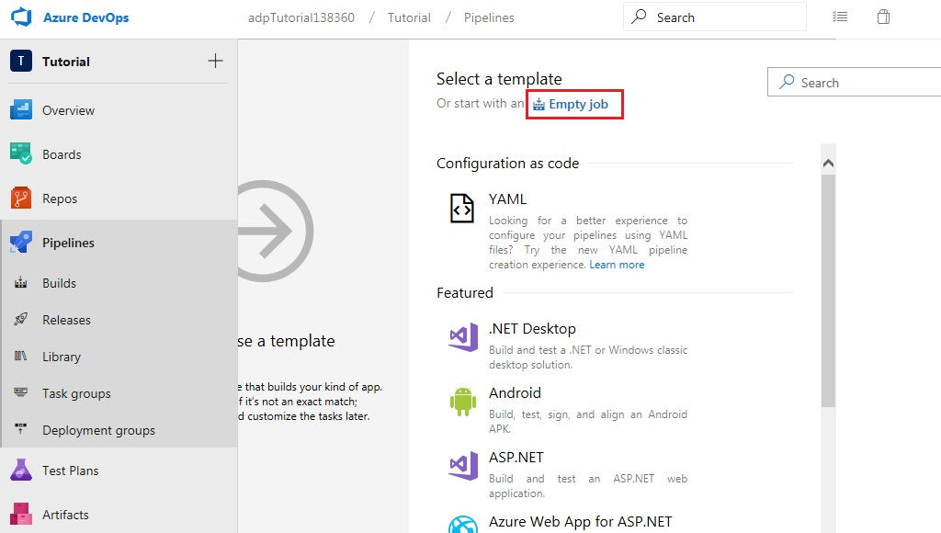

Give a Name to the pipeline and select ‘Hosted VS2017’ as the ‘Agent pool’

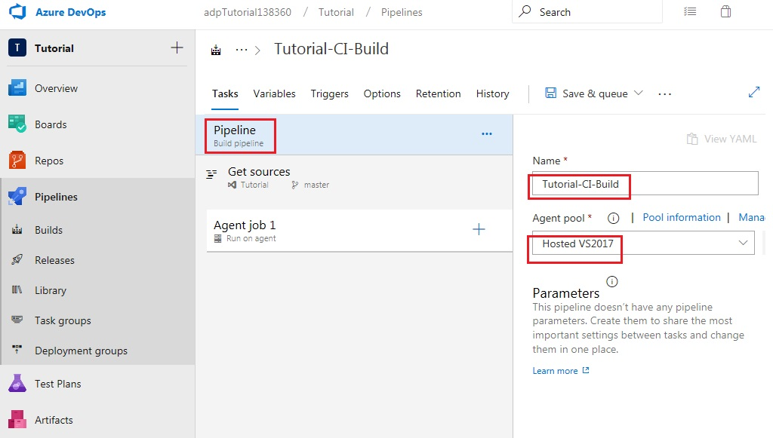

Proceed by adding five tasks to job 1

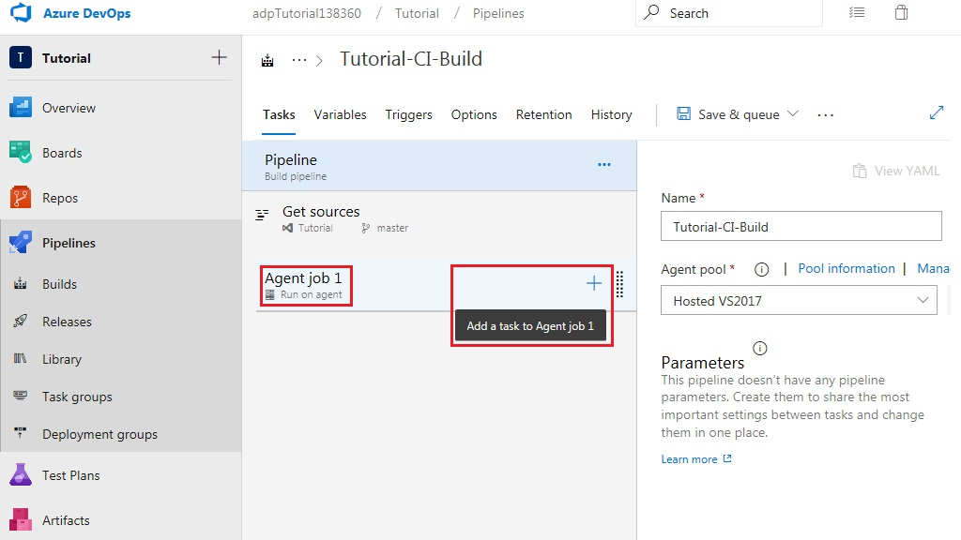

Add the ‘NuGet Tool Installer’ from the ‘Tool’ tab

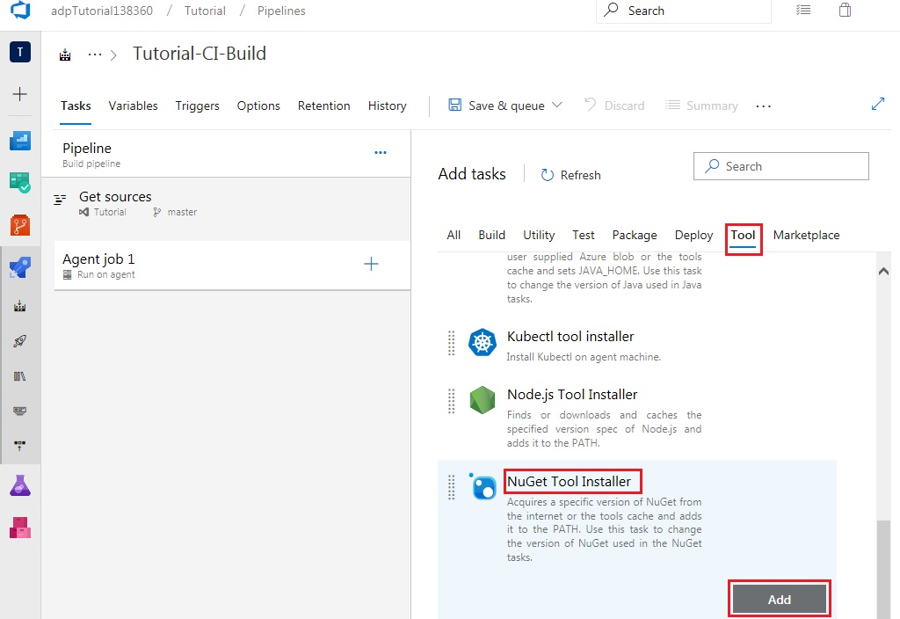

Add ‘NuGet’ from the ‘Package’ tab

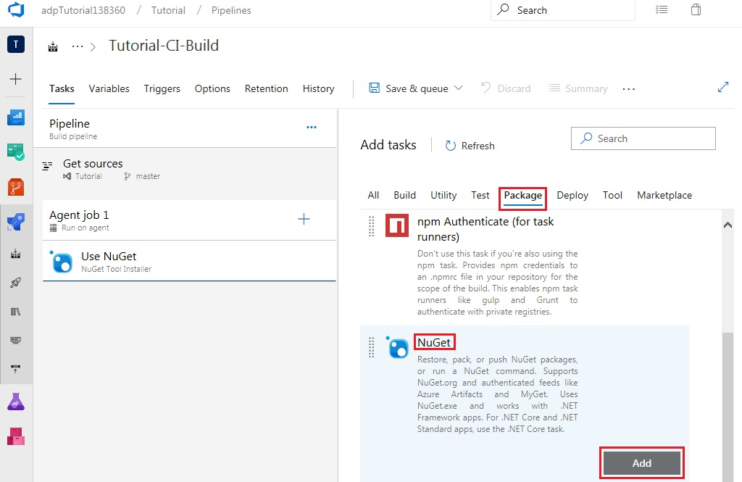

Add ‘Visual Studio Build’ from the ‘Build’ tab

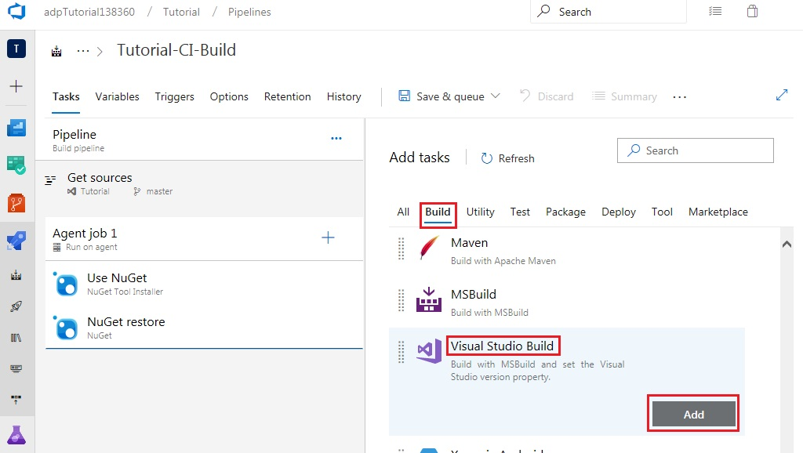

Add ‘Copy Files’ from the ‘Utility’ tab

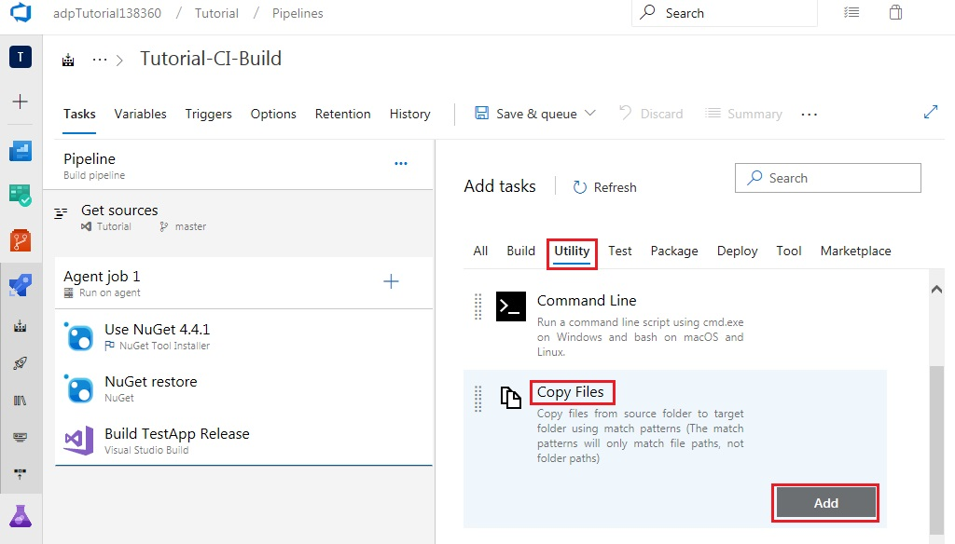

Finally, add ‘Publish Build Artifacts’ from the ‘Utility’ tab

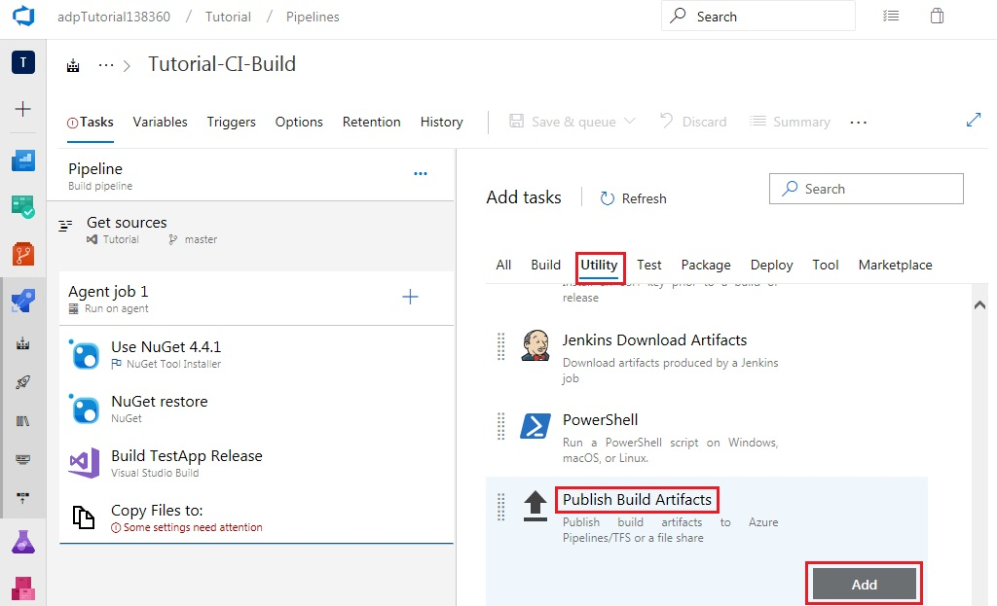

Select the ‘NuGet Tool Installer’ on the left-hand side and specify version 4.4.1

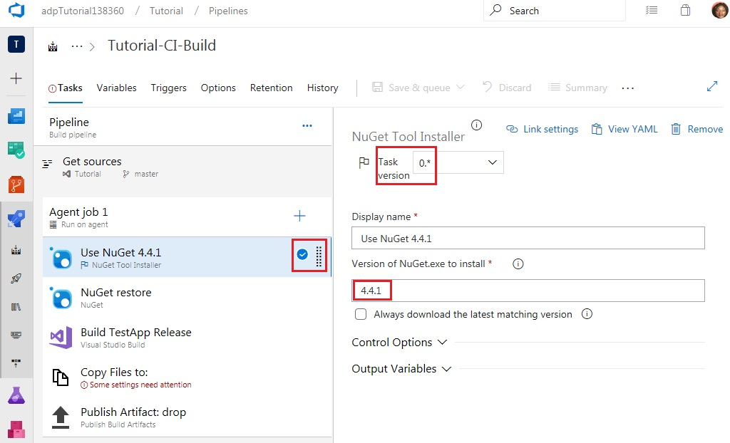

Select ‘Visual Studio Build’ on the left-hand side, specify a Display name, check the ‘Clean’ box and specify the Platform and Configuration

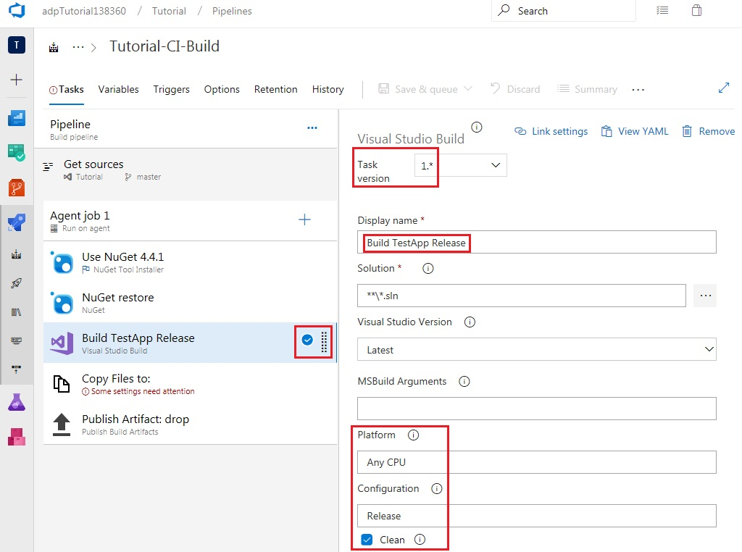

Select ‘Copy Files’ on the left-hand side, specify a Display name and set the Contents and Target Folder as shown.

Note that the Target Folder, $(Build.ArtifactStagingDirectory), will be the same one used in the Path to publish field of the final task, Publish Build Artifacts.

The first line of the contents field indicates that all items in any bin\Release folders present within the repository will be copied. The second line indicates that all items in any obj folders present within the repository will be excluded from being copied.

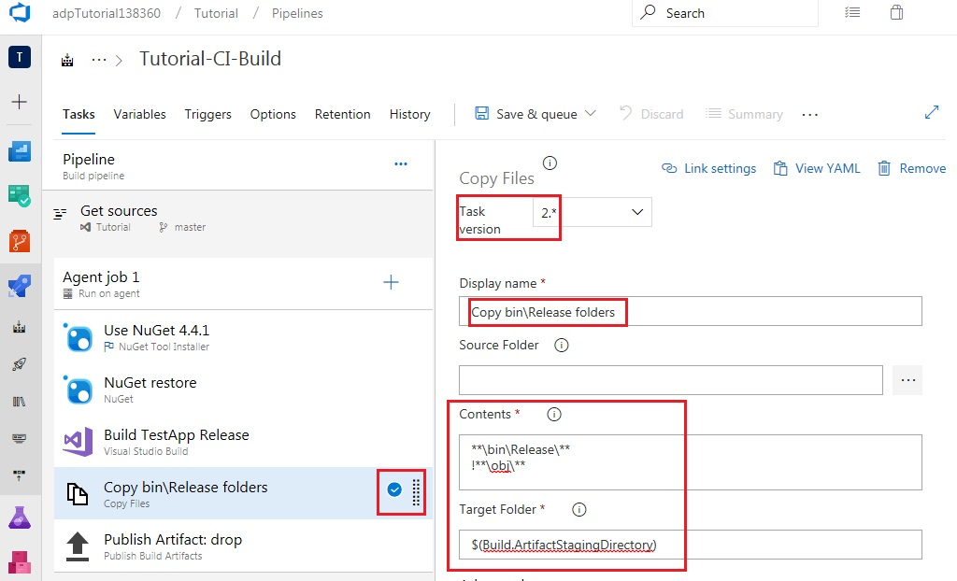

Select ‘Publish Build Artifacts’ on the left-hand side and specify both a Display name and an Artifact name.

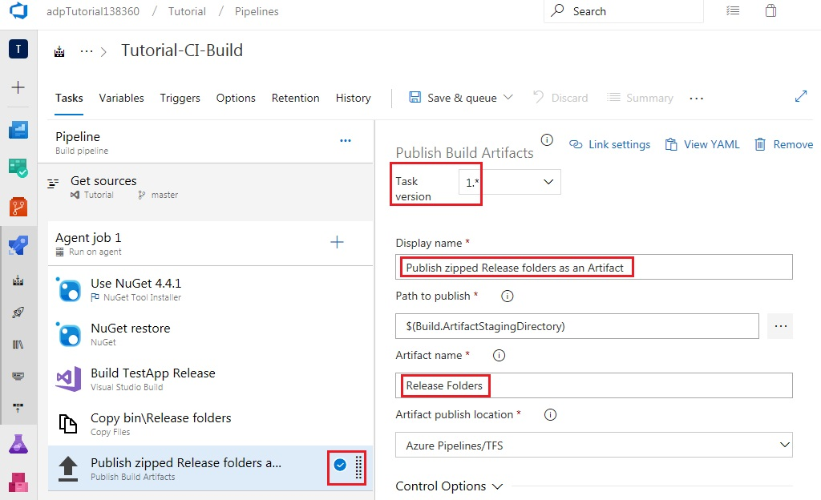select CI on the Triggers tab

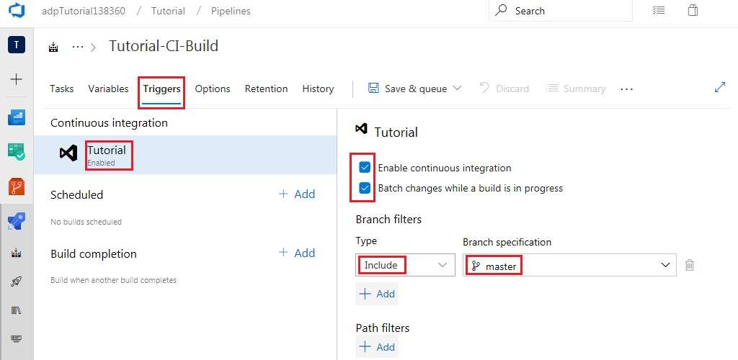

Set work item related options as follows

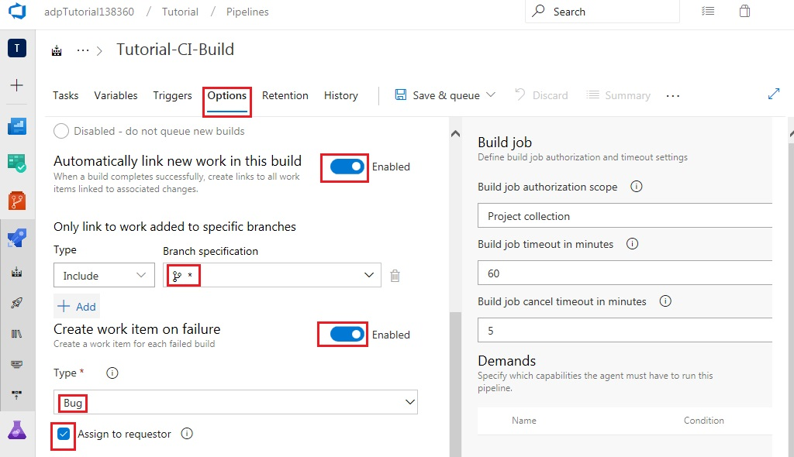

Save and queue

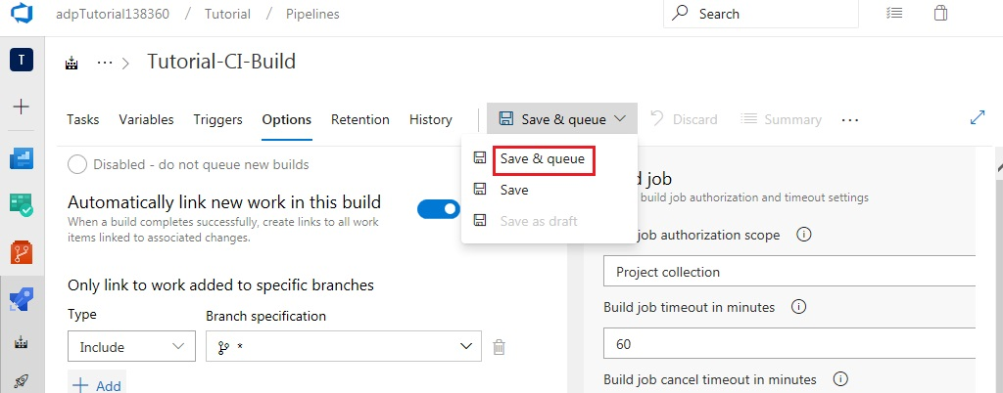

Select ‘Save & queue’ again

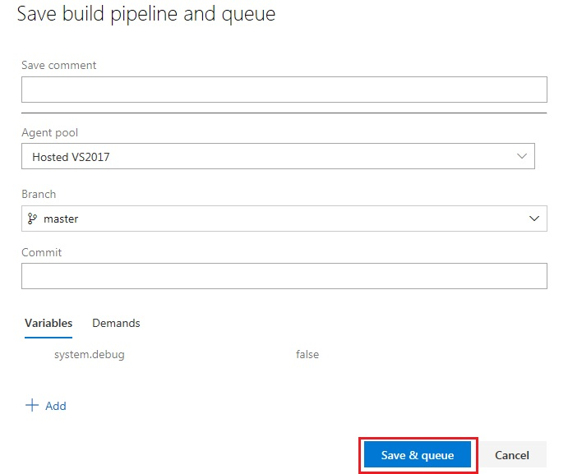

Click on the link to the newly created build

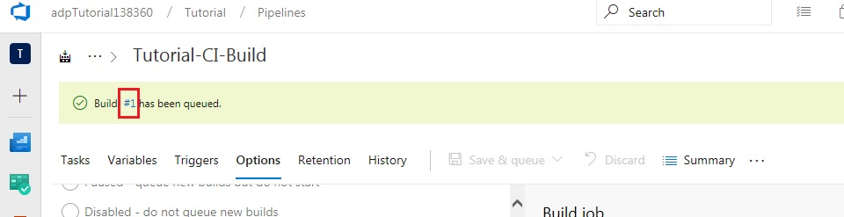

Click the Logs tab to see the build tasks running live

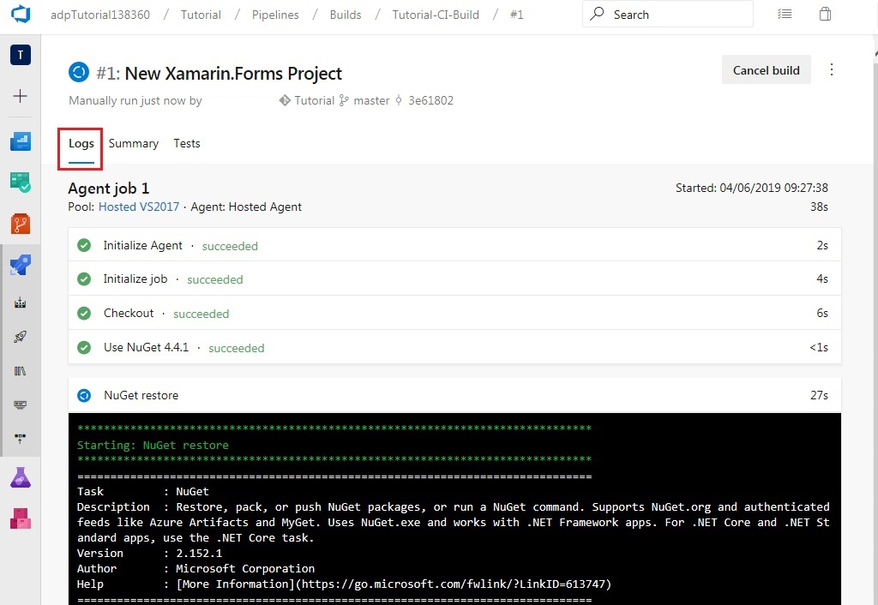

Once all tasks succeed, the build artifacts can be viewed as follows

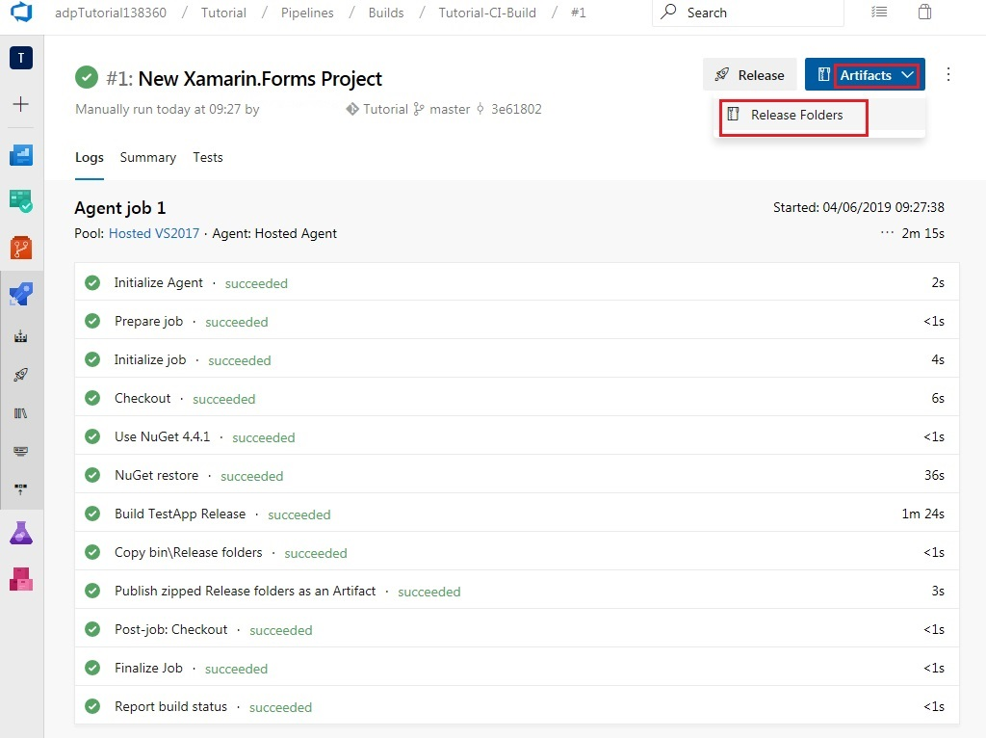

Release DLLs can be viewed in the Artifacts explorer

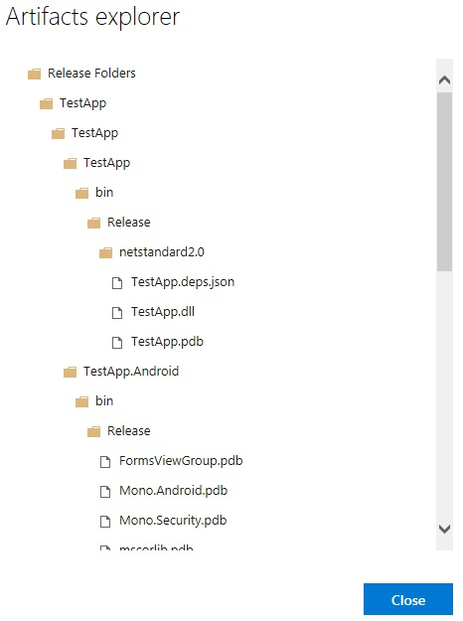

Close the Artifacts explorer and navigate to the builds pipeline. This will show that the first build which was run was a Manual build.

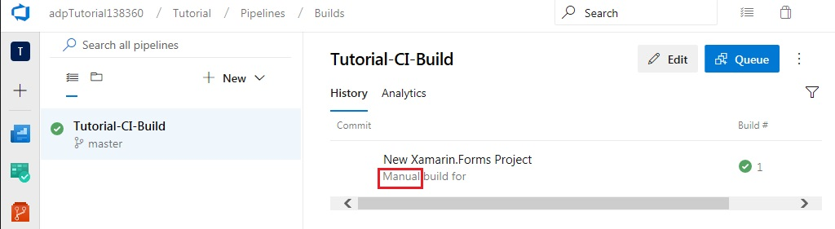

Return to Visual Studio 2017 to trigger a rolling build through a code change. From the Solution Explorer window, expand the TestApp project and open MainPage.xaml.

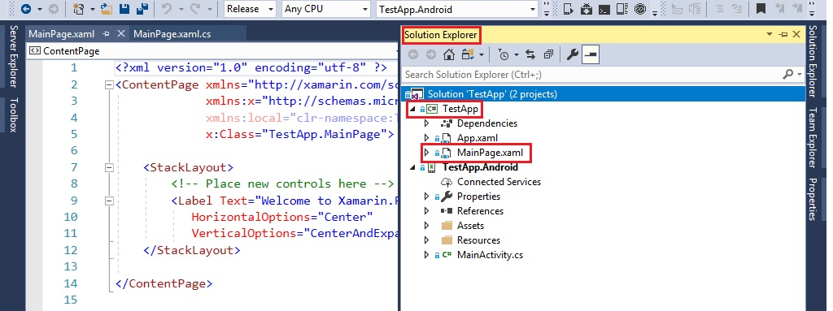

Modify the code as follows and build your Solution

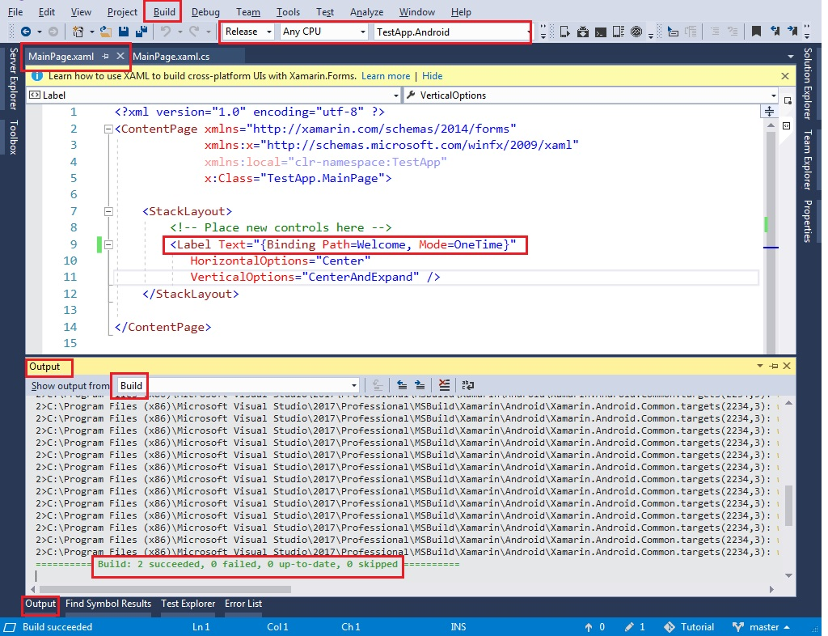

Now, open the Team Explorer window in Visual Studio. Click on the ‘Changes’ button under the ‘Home’ tab.



Add an appropriate comment and click Commit All

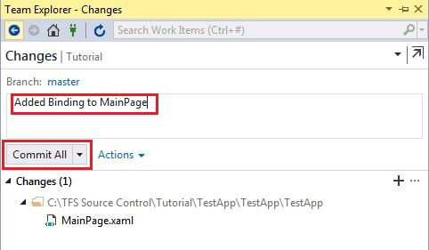

Click on the ‘Sync’ button under the ‘Home’ tab of the Team Explorer window in Visual Studio and ‘Push’ your commit to the server.

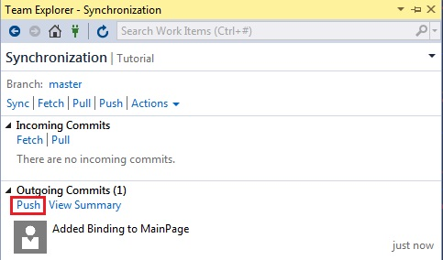

Return to your web browser and refresh the builds pipeline or access it using the following link: [https://dev.azure.com/orgname}/{projectname}/_build?definitionId=1](https://dev.azure.com/adpTutorial138360/Tutorial/_build?definitionId=1)

This should now display the Rolling build which was triggered by your code change.

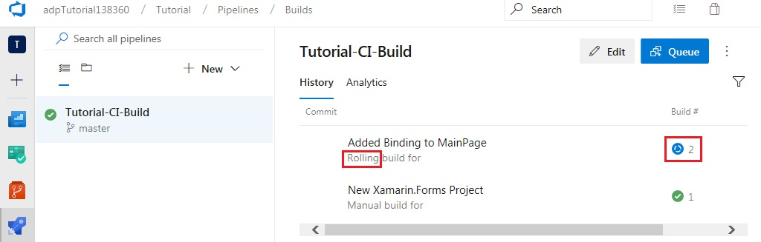

Return to Visual Studio to make a code change which will cause the build to fail. From the Solution Explorer window, expand the TestApp project and open MainPage.xaml.cs.

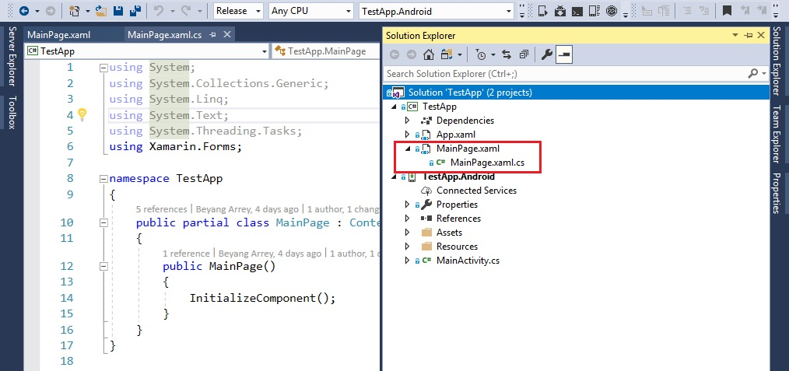

Modify the code as follows and build your Solution

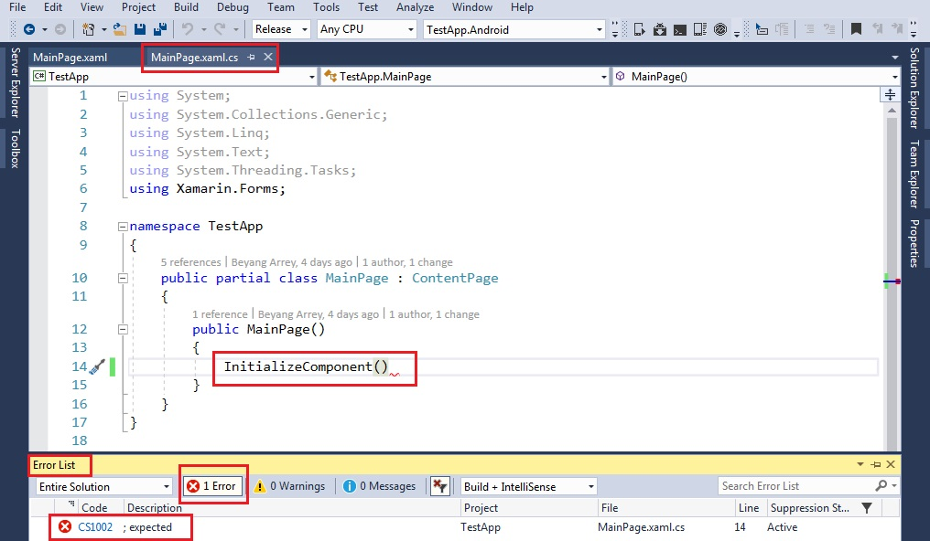

Now, open the Team Explorer window in Visual Studio. Click on the ‘Changes’ button under the ‘Home’ tab. Add an appropriate comment and click Commit All. Click on the ‘Sync’ button under the ‘Home’ tab of the Team Explorer window in Visual Studio and ‘Push’ your commit to the server. Return to your web browser and refresh the builds tab. Click on the failed build to view the details.

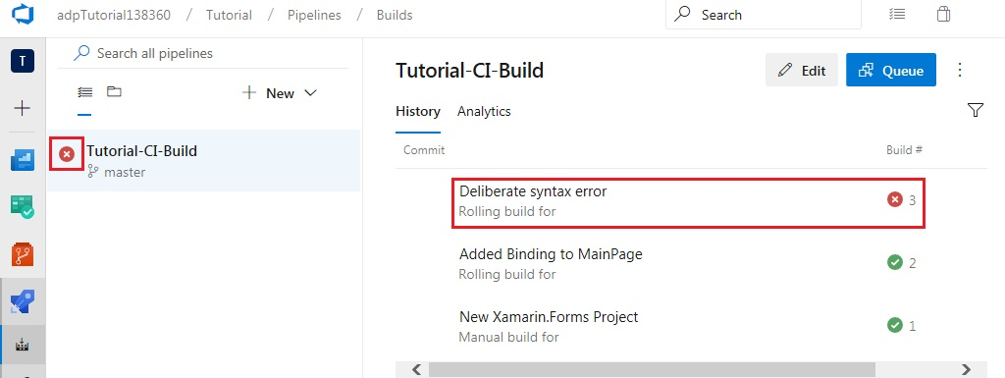

Click the Summary tab and observe that a new Bug has been created as a work item

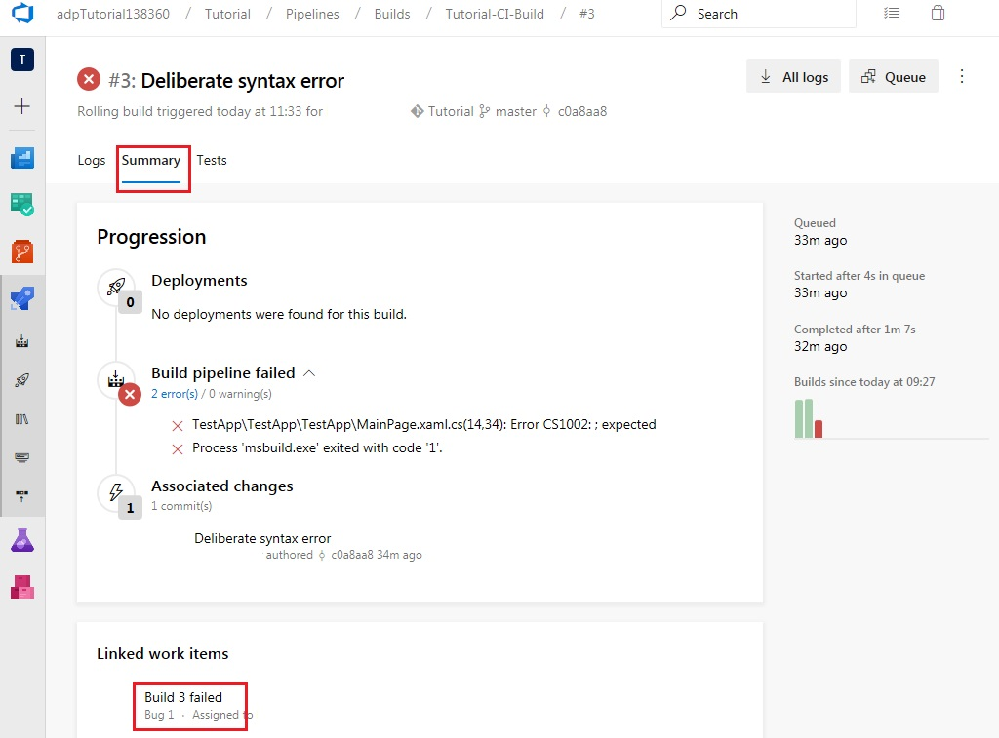

A query can be executed to view all bugs present in the repository by selecting Queries

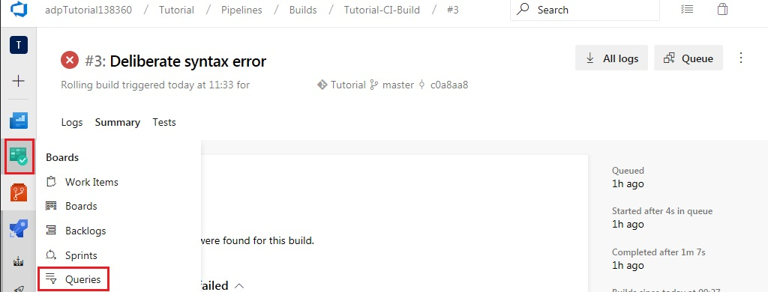

Add a new query

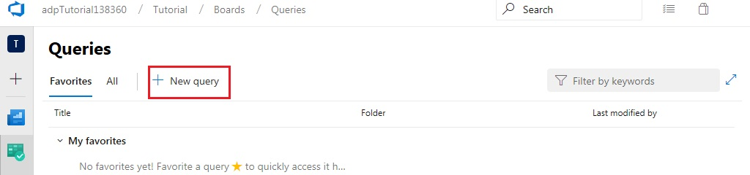

Add clauses as shown below and click Run query to view the list of bugs. You can click on the bug to view details, history and links.

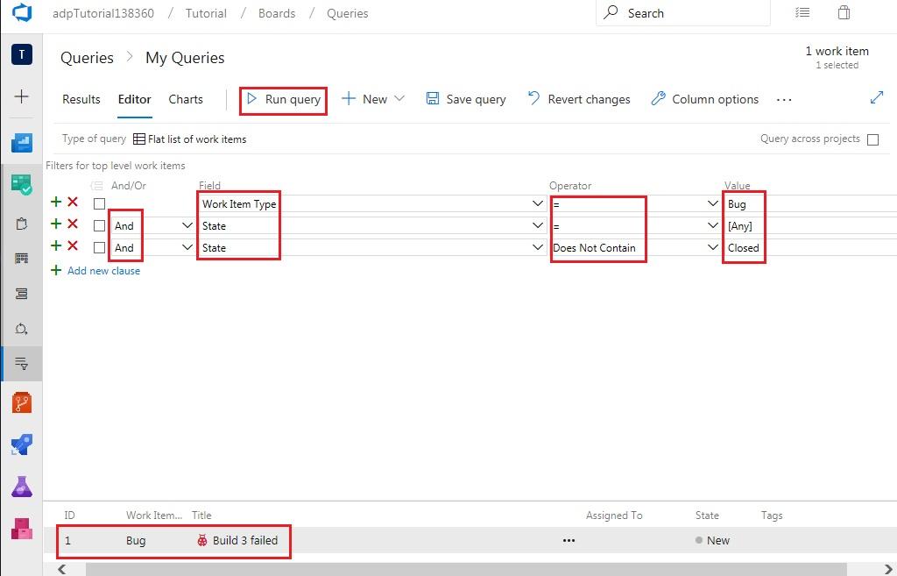

Click Save query, enter an appropriate name and select the ‘Shared Queries’ folder. Click OK.

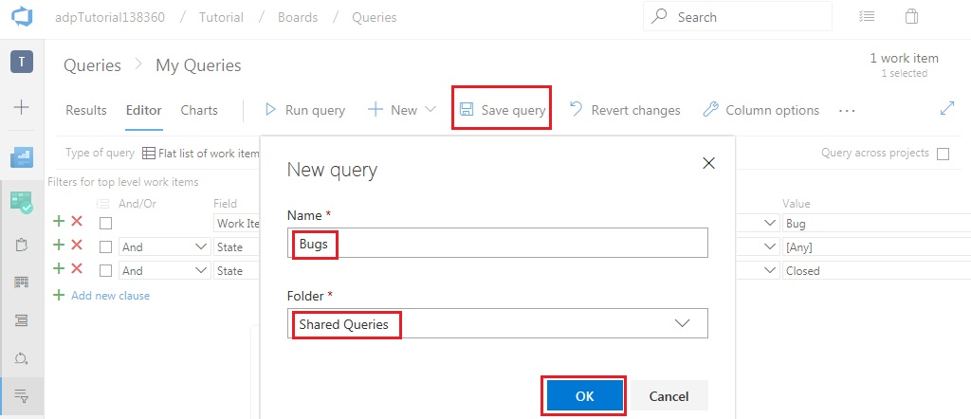

Setting up the release pipeline

Navigate to the Releases pipeline

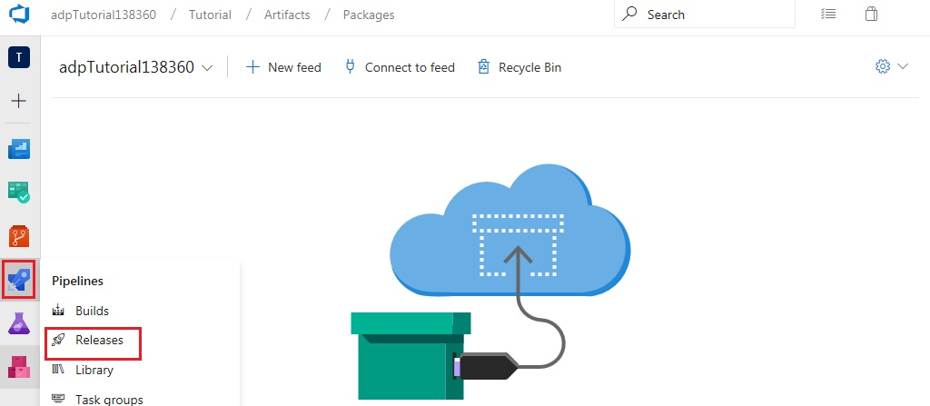

Click ‘New Pipeline’

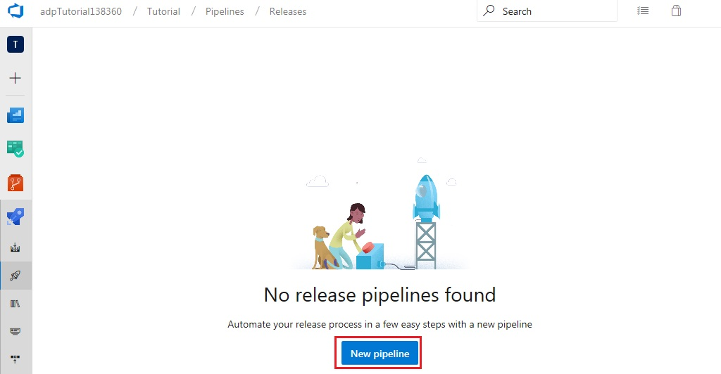

Click ‘Empty job’

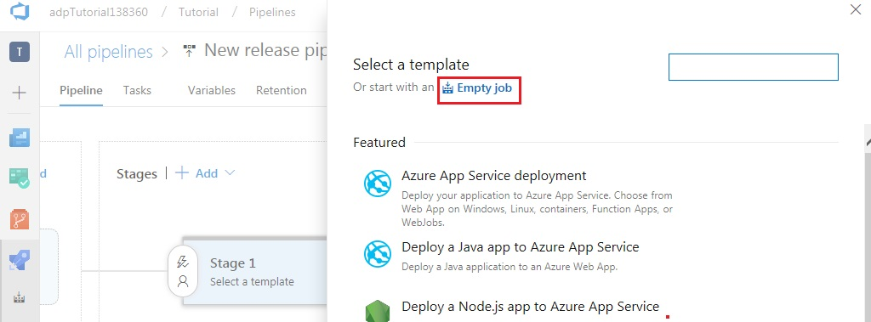

Give the stage a name and close the modal

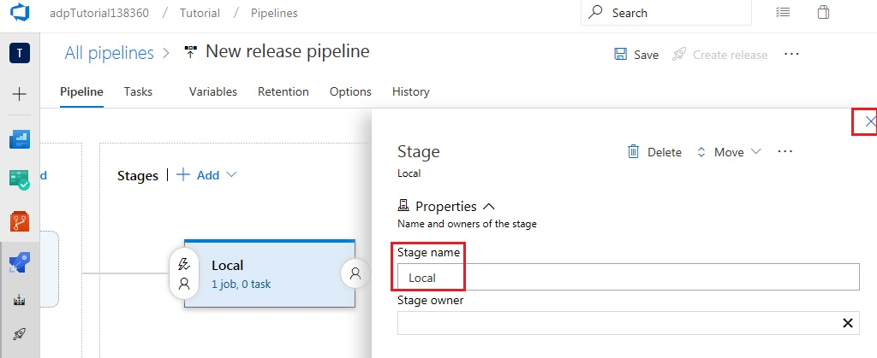

Add an artifact

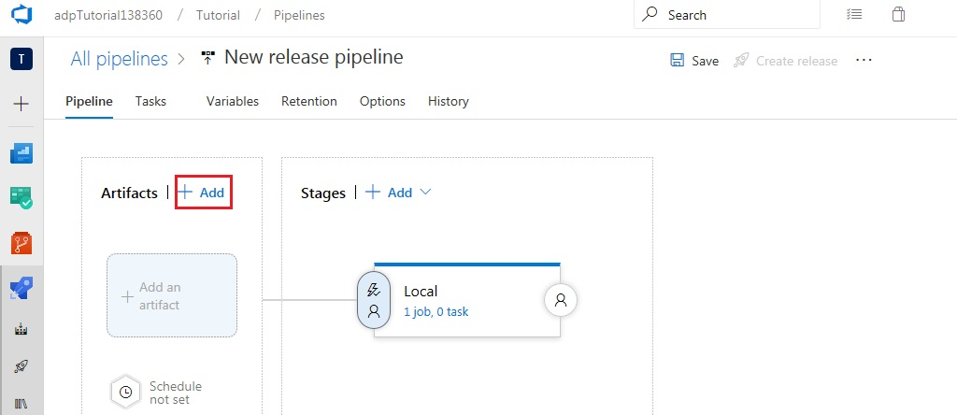

Select the build pipeline 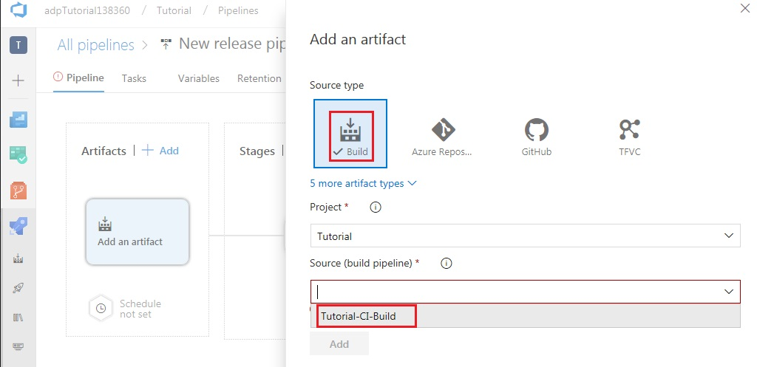

Select the latest version and click ‘Add’

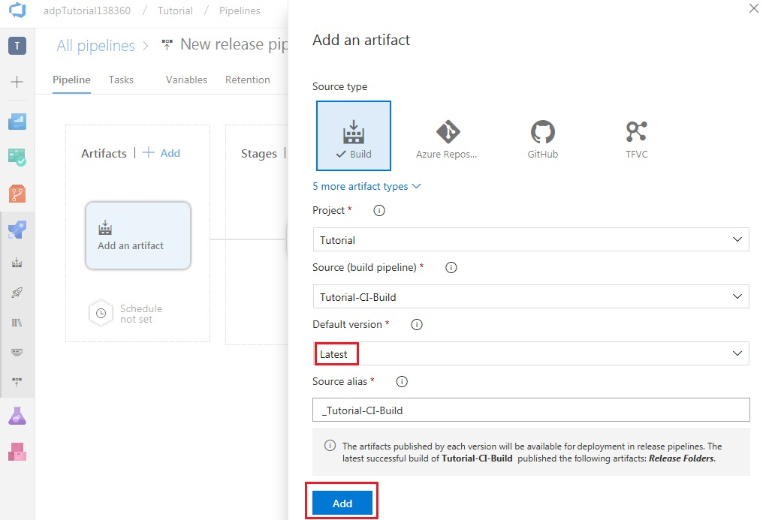

Enable continuous deployment

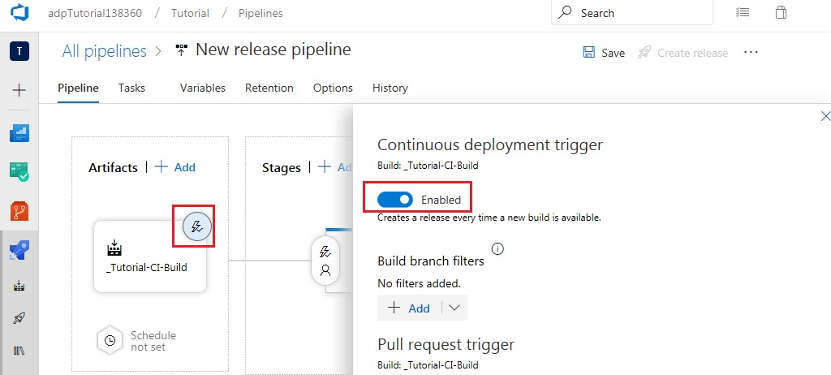

Add the Download Build Artifacts task to the job

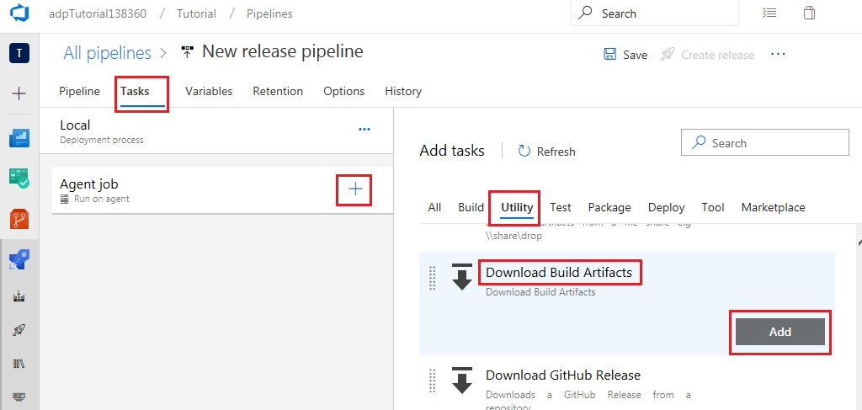

Configure the new task as shown, provide a suitable name and save.

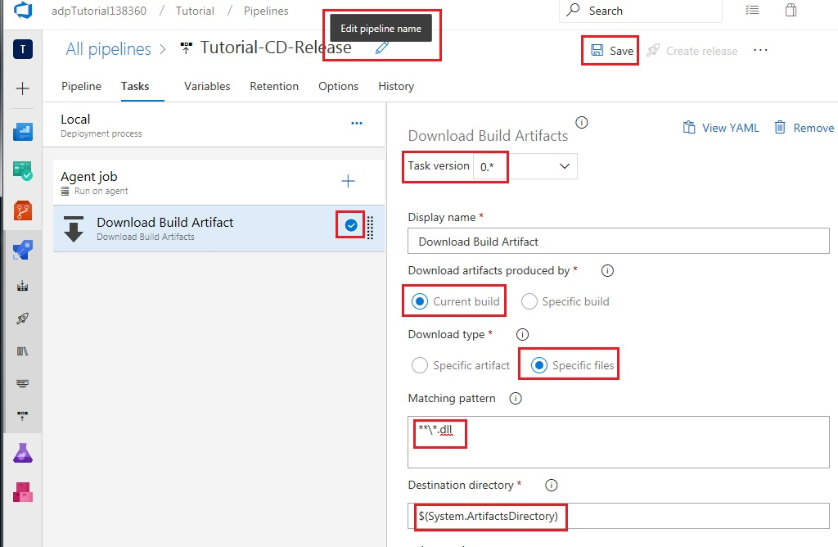

Click OK

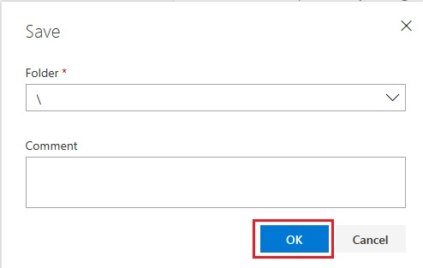

Click on the Releases pipeline to view the new pipeline

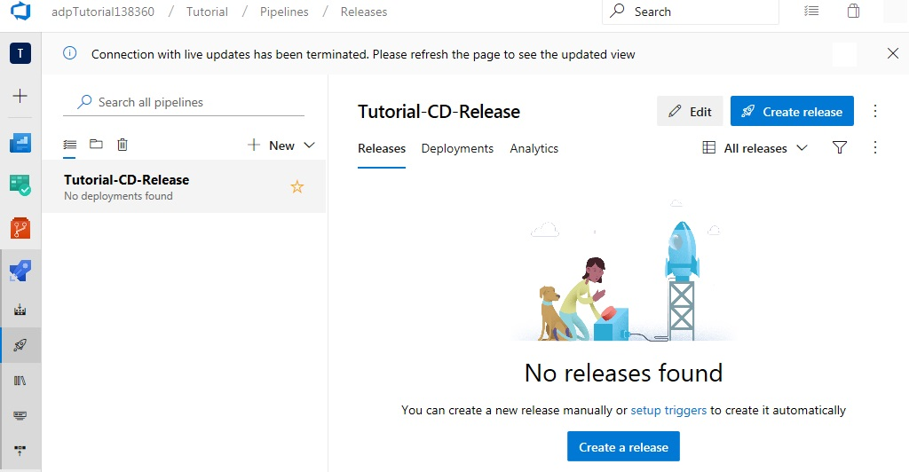

Return to Visual Studio to trigger a build and release. From the Solution Explorer window, expand the TestApp project and open MainPage.xaml.cs.

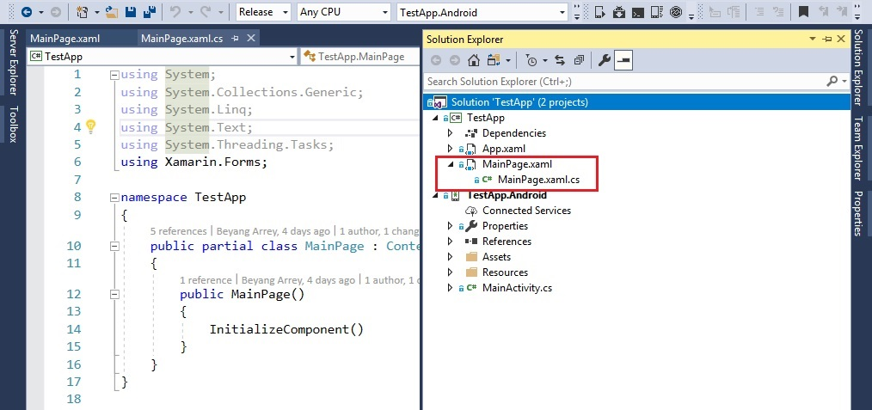

Modify the code as follows and build your Solution

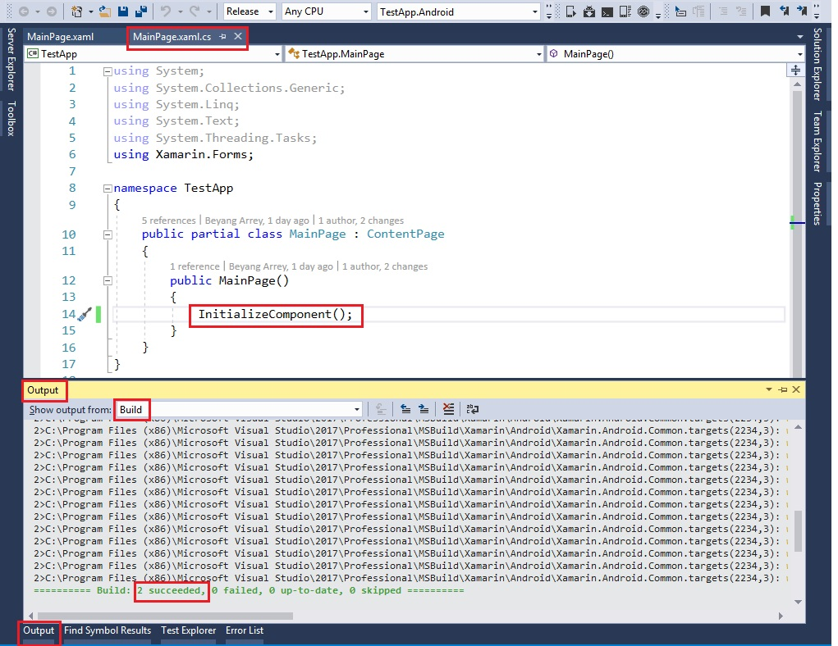

Now, open the Team Explorer window in Visual Studio. Click on the ‘Changes’ button under the ‘Home’ tab. Add an appropriate comment and click Commit All. Click on the ‘Sync’ button under the ‘Home’ tab of the Team Explorer window in Visual Studio and ‘Push’ your commit to the server. Return to your web browser and open the builds tab. Once the build succeeds, navigate to the release pipeline to view the current release

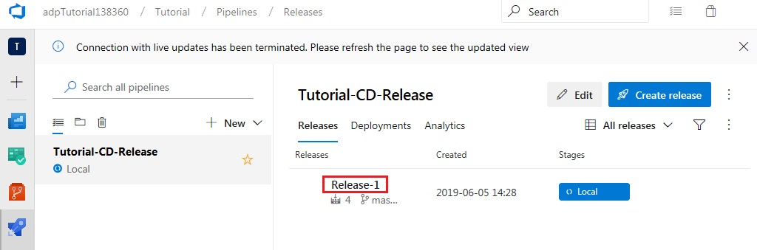

Finished the Basic release pipeline

Deployment to app center

Navigate to the builds tab, click edit and Add 2 more tasks to the build pipeline

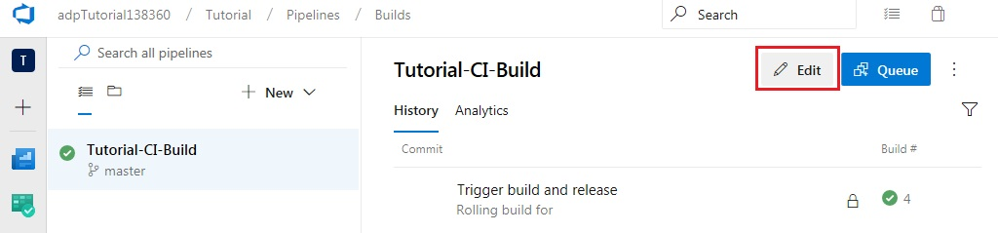

Add the Xamarin.Android task from the ‘Build’ tab

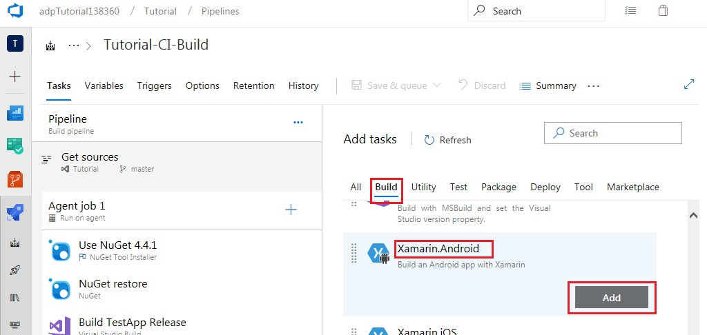

Add the Android signing task from the ‘Build’ tab

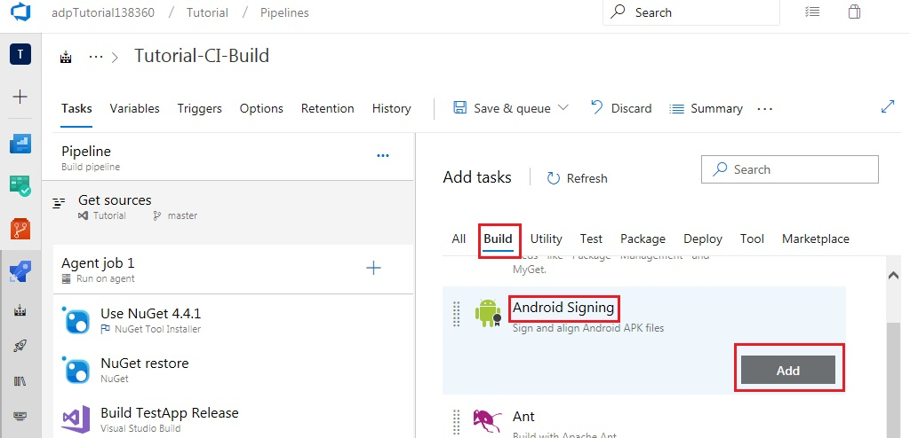

Move both Android tasks above the Copy Files task

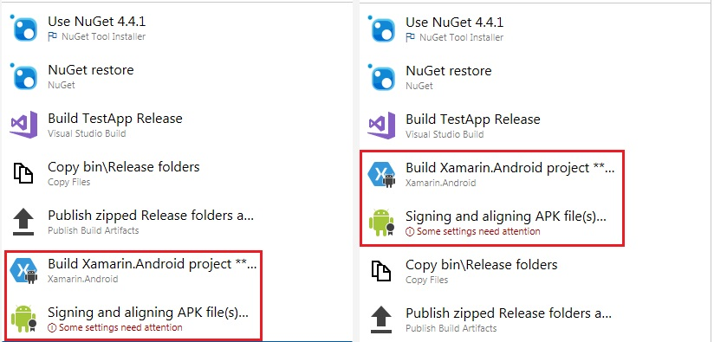

Configure the Xamarin.Android task as follows

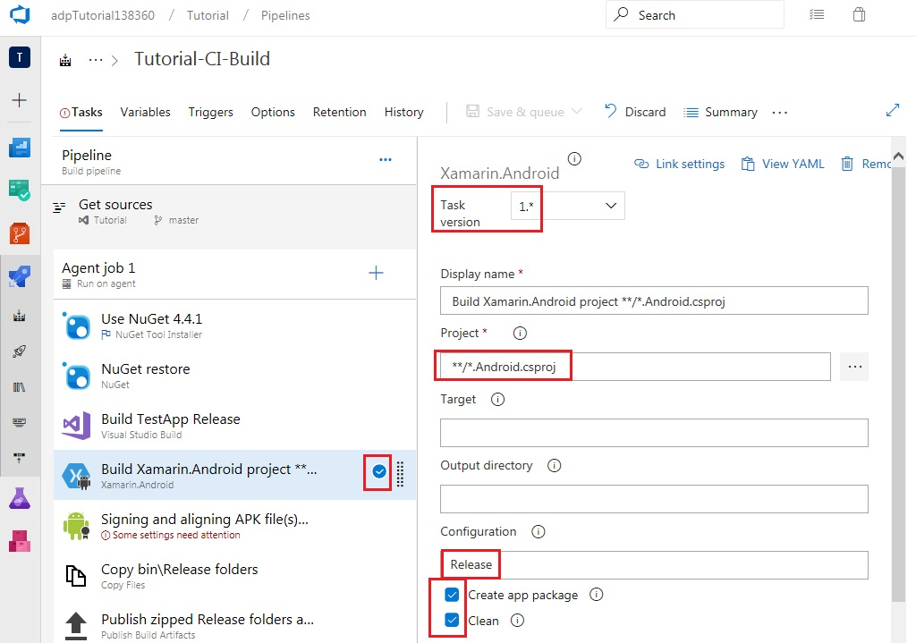

Return to Visual Studio to generate a keystore file. From the Solution Explorer window, right-click on the Android project and select Archive

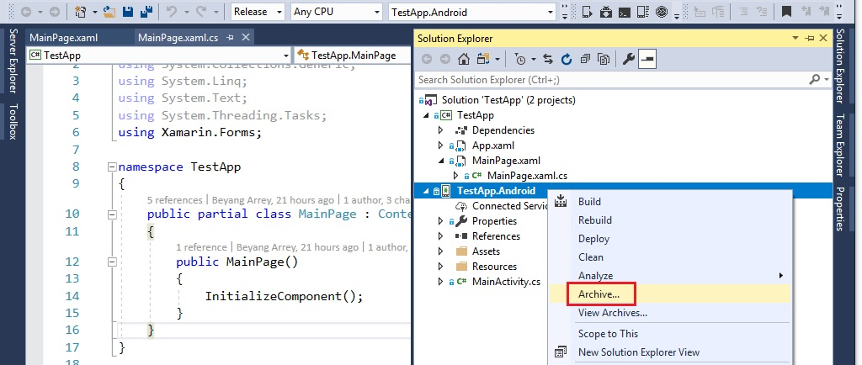

When the Archive Manager opens up, click Distribute

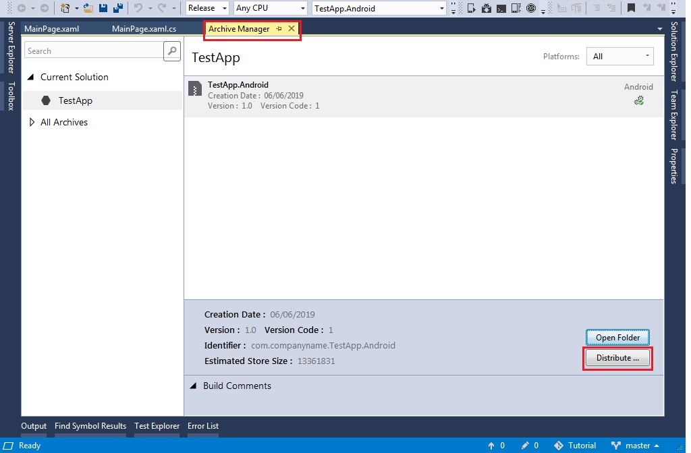

Select Ad Hoc

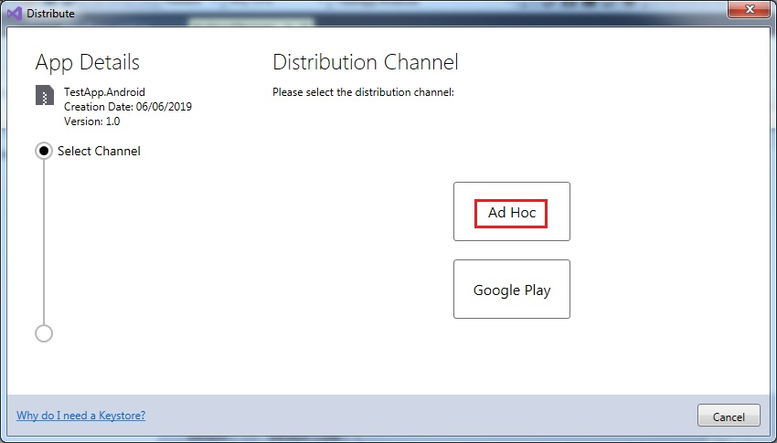

Add a new Signing Identity

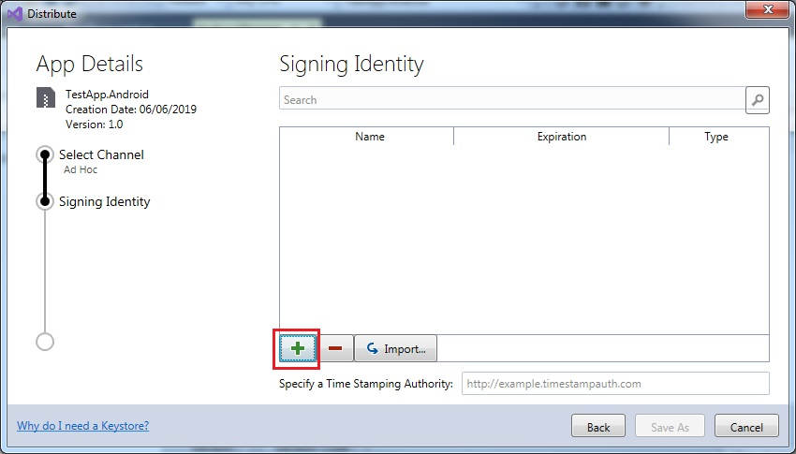

Enter required details and click Create. Keep a record of the password provided as it will be needed later

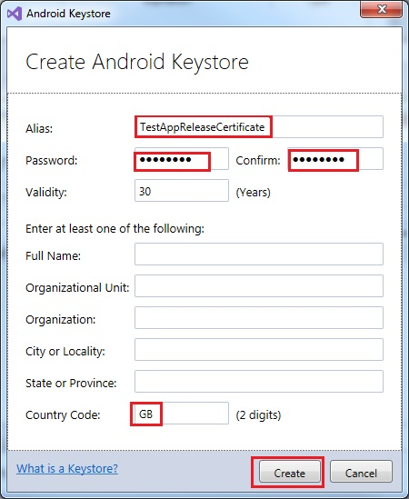

Double click the certificate to view its details

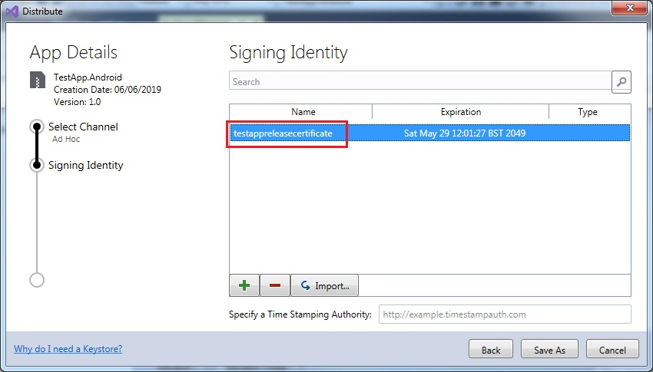

Click View in Explorer

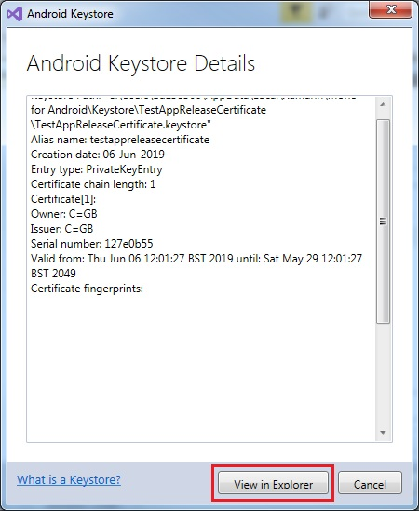

This should open a windows explorer window with the keystore file

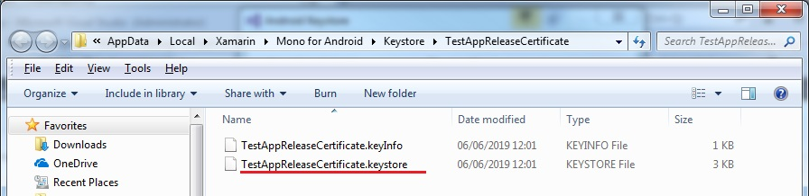

Return to your browser and upload the keystore file to the Android signing task

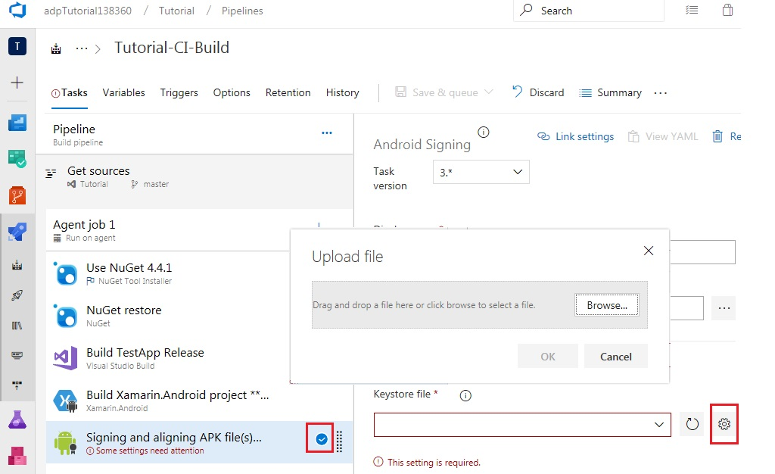

Configure the Android signing task as follows

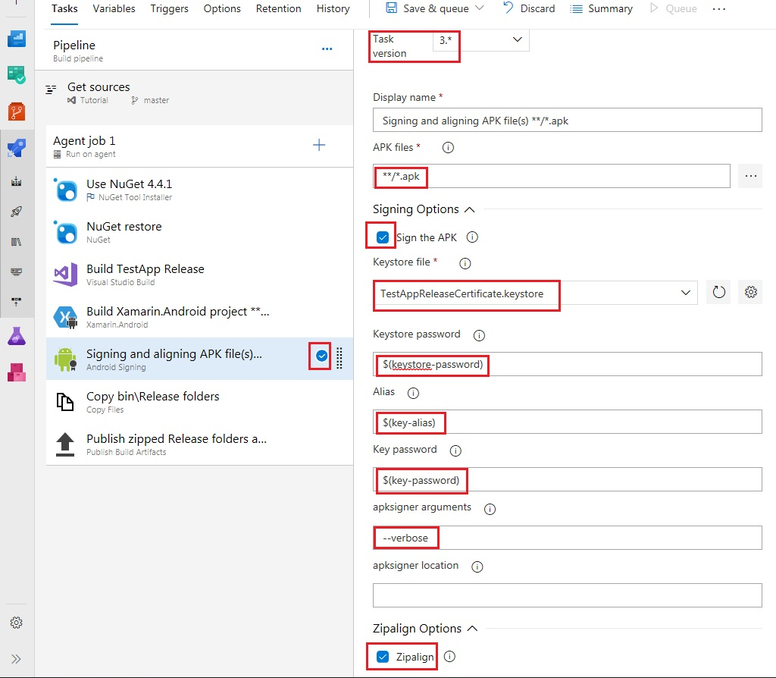

Navigate to the Variables tab to add the keystore variables used in the Android signing task

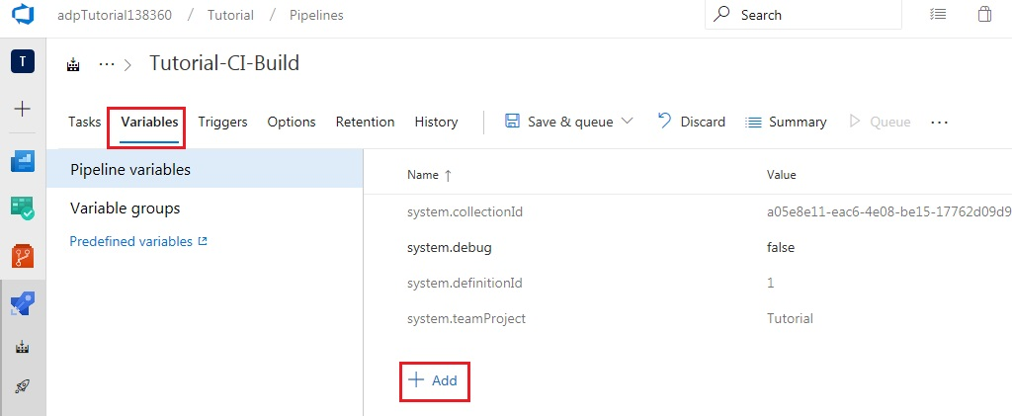

Configure the variables as shown below, using the same alias and password which was provided when creating the keystore in Visual Studio. Make sure to lock the password variables. Then, click Save & queue

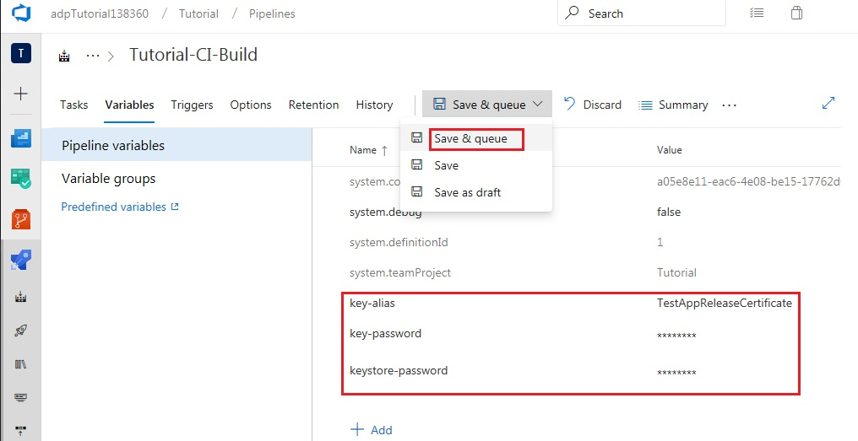

Click on the new build to verify the logs

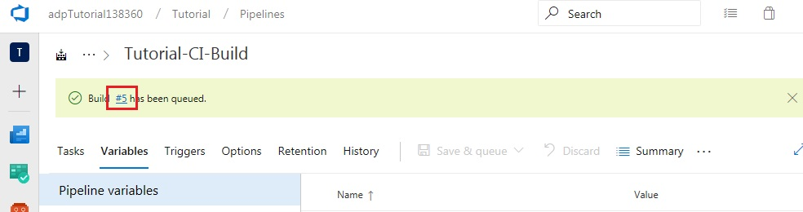

The build should complete successfully. Note that the Xamarin.Android project may generate a few warnings. These can be ignored. More information on the warnings can be found here: <https://developercommunity.visualstudio.com/content/problem/549446/vs-19-community-no-debug-symbols-file-was-found-wh.html>

Once the build succeeds, browse the artifacts directory to ensure that a .apk file is present

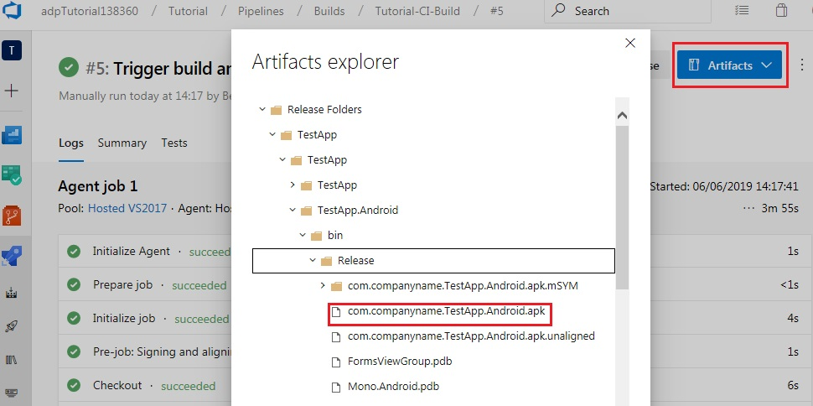

Close the artifacts explorer, navigate to the releases pipeline and click edit

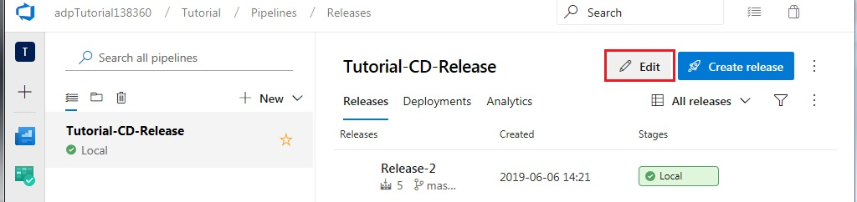

Navigate to the tasks tab and add the App Center Distribute task from the Deploy tab

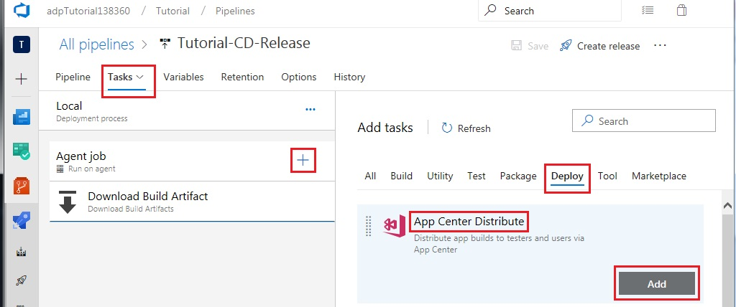

Create an API token in app center by accessing the following link: <https://appcenter.ms/settings/apitokens> and selecting New API token

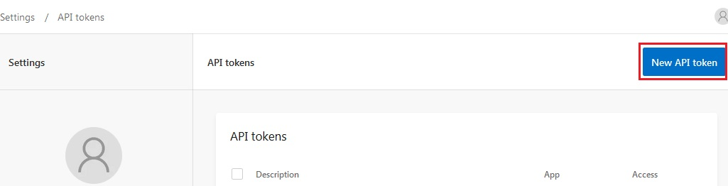

Enter the name which was previously used to register the app on the app center dashboard, select full access and click Add new API token

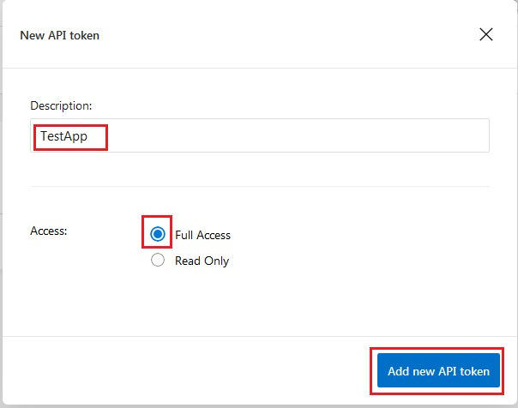

Copy the token and return to the App Center Distribute task which was added to the release pipeline.

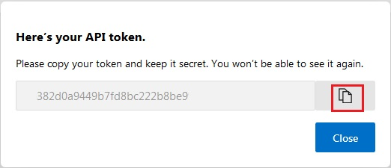

Add a new App Center service connection

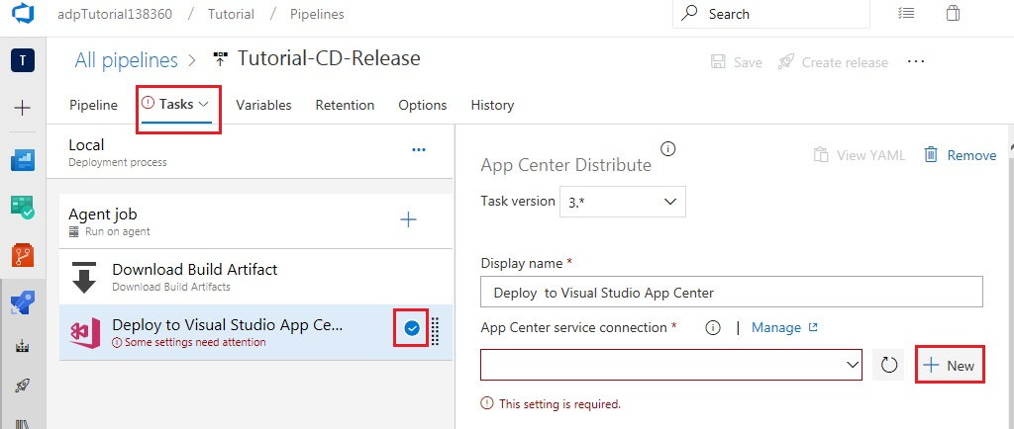

Enter the app name and paste your API token which was copied from app center. Then click OK

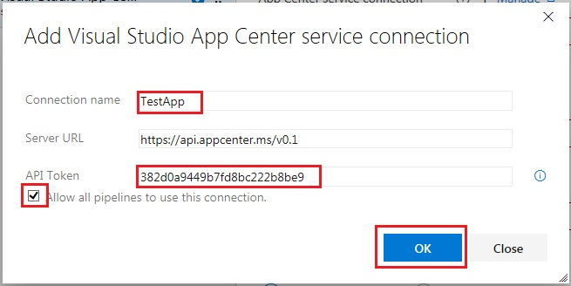

Configure the app slug to be your app center username followed by /TestApp or whatever name was previously used to register your app on the app center dashboard.

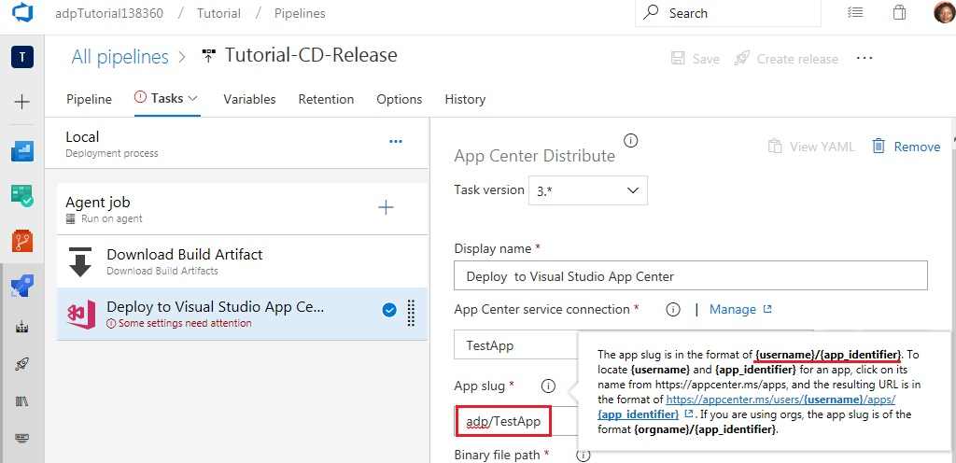

For the Binary file path, browse to select the .apk file which was created during the Android signing task and click OK

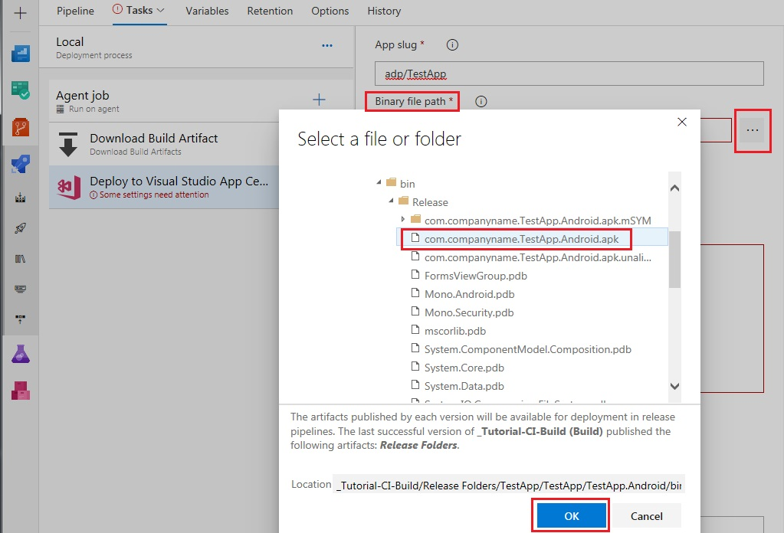

Enter release notes, select release destination and click Save

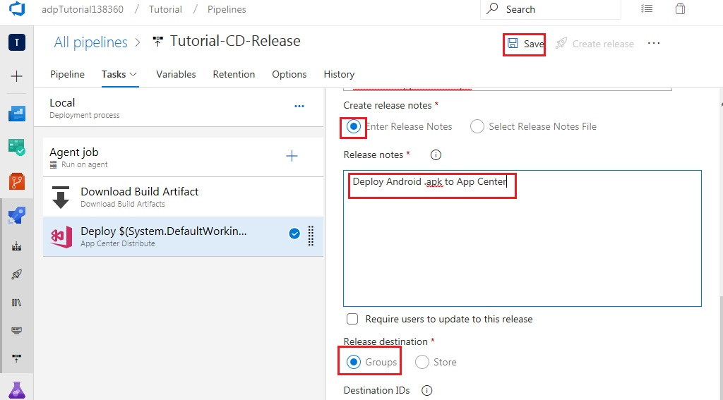

Enter a comment and click OK

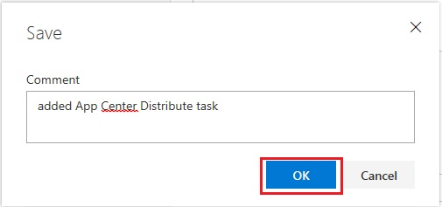

Return to the Pipeline tab and clone the Local stage

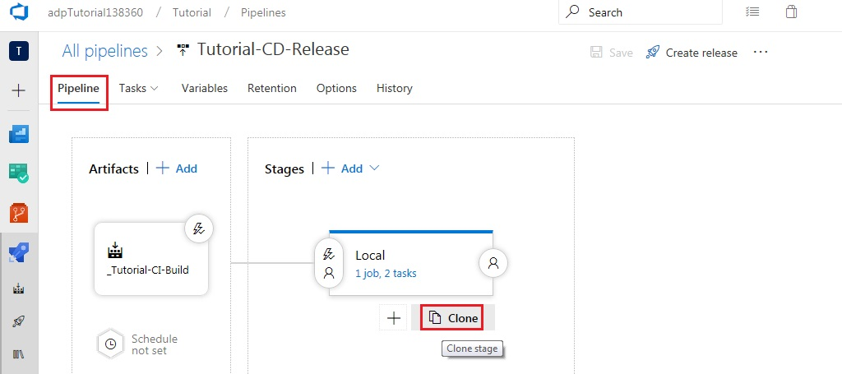

Select the new stage and change the name to Production and click Save

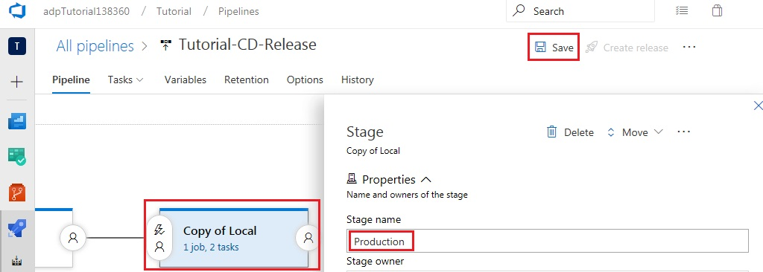

Enter a comment and click OK. Then click Create release

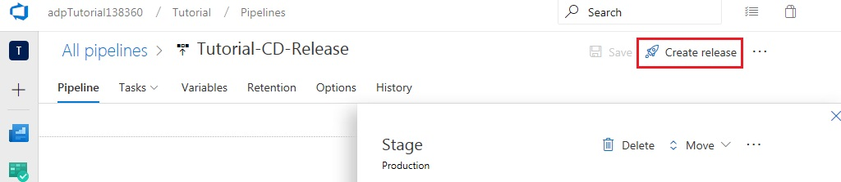

Enter a description and click Create

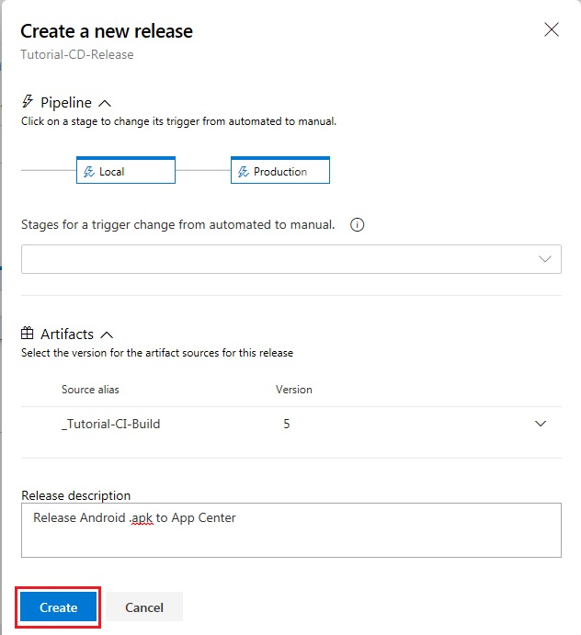

Click the new Release to view the details

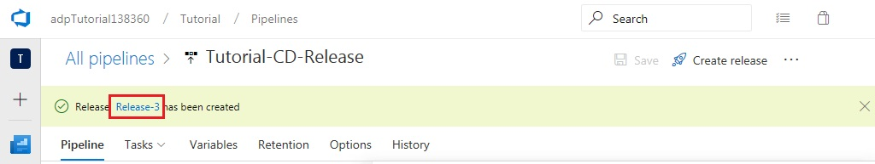

Both stages of the pipeline should complete successfully

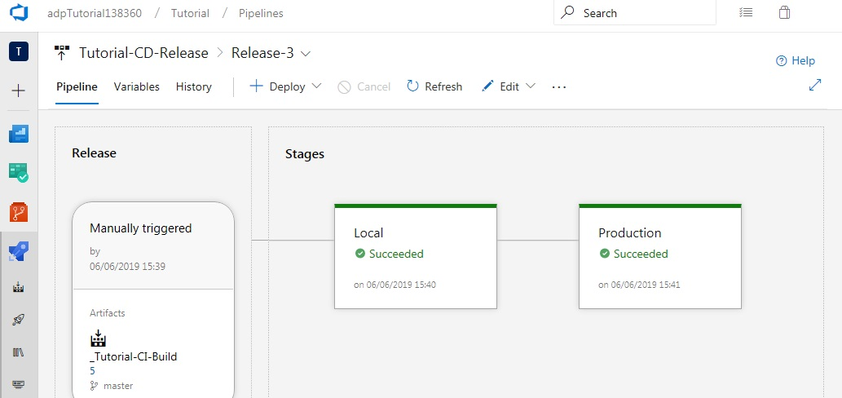

Navigate to the following link to view the release in App Center, [https://appcenter.ms/users/{username}/apps/TestApp/distribute/releases/1](https://appcenter.ms/users/%7busername%7d/apps/TestApp/distribute/releases/1)

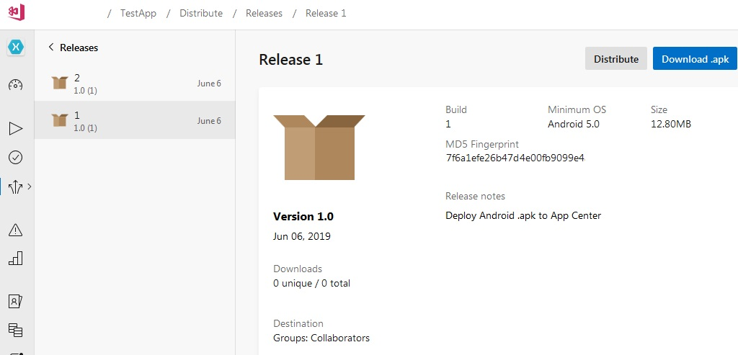

Additional features

Deployment gates

Navigate to the releases pipeline and click Edit. Select pre-deployment conditions for the Local stage

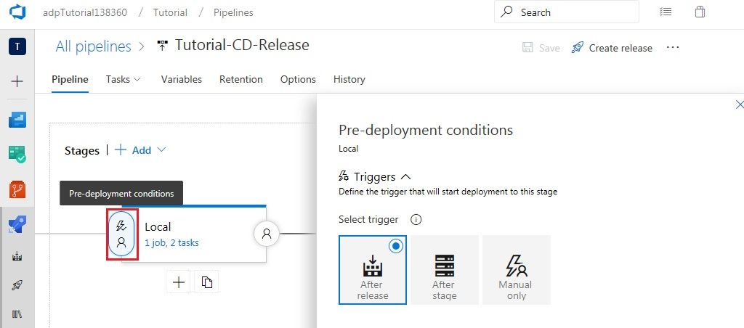

Enable Gates and add the Query Work Items gate

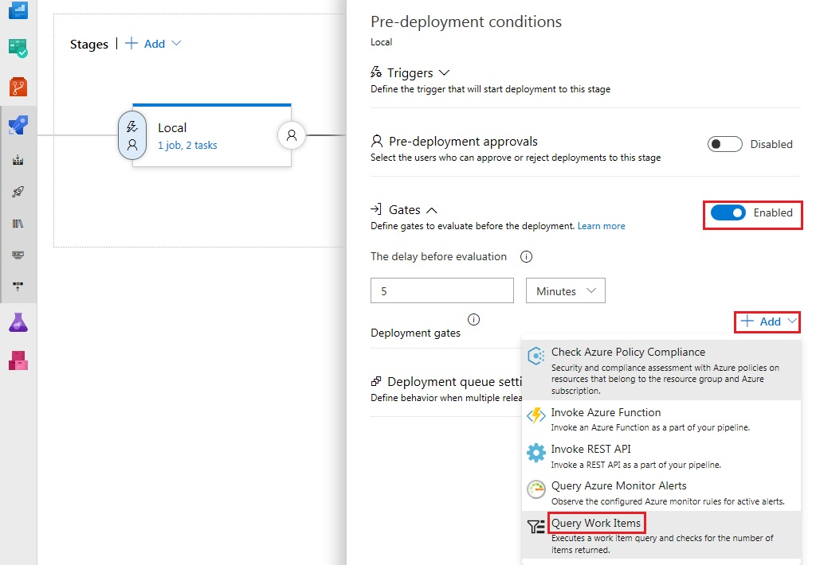

Select the Bugs query which was previously created when setting up the build pipeline to create a work item on build failure

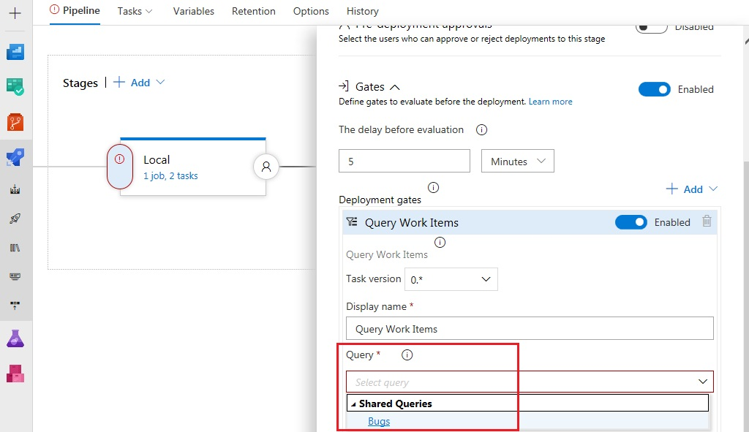

Change the evaluation options as follows to enable quicker results

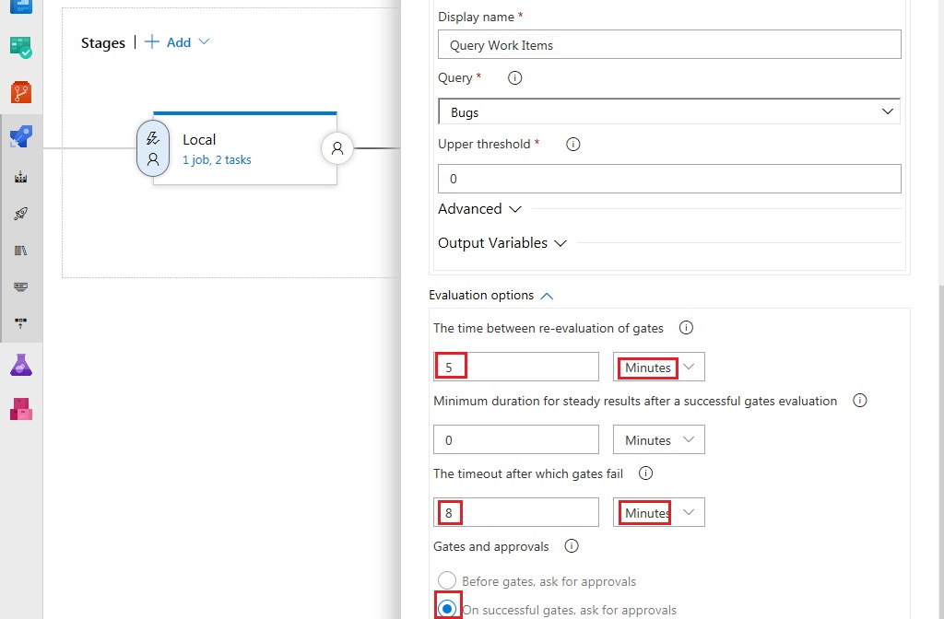

Close the pre-deployment conditions and click on post deployment conditions. Enable post-deployment approvals and put yourself as an approver. Note that, in a production environment the box indicating that ‘The user requesting a release or deployment should not approve it’ should be checked. However, for demonstration purposes, this should be left unchecked.

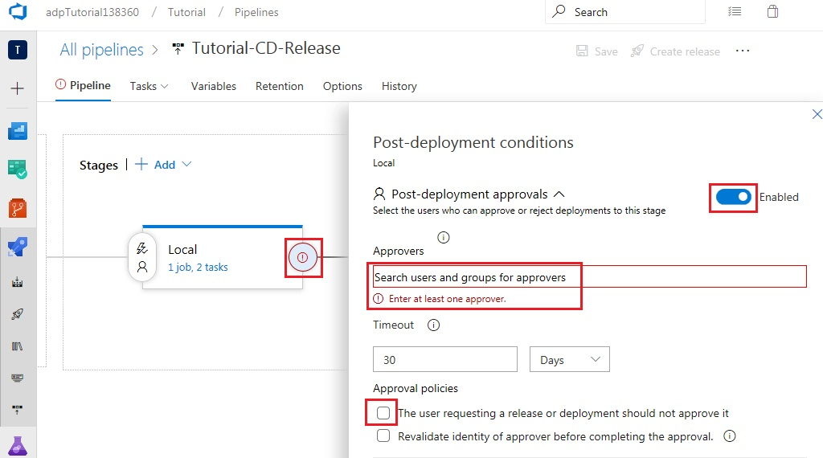

Close the post-deployment conditions, save the changes and Create a release. Once the release is in process, click on the logs for the local stage to view the details. The stage should fail due to the existing bug on the repository

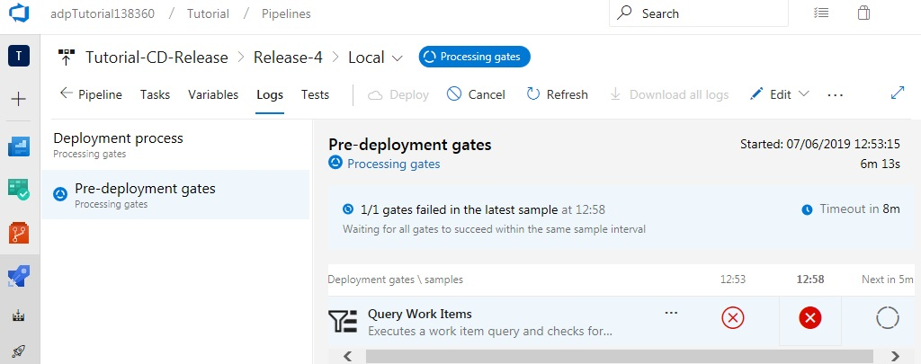

Navigate to the query created previously

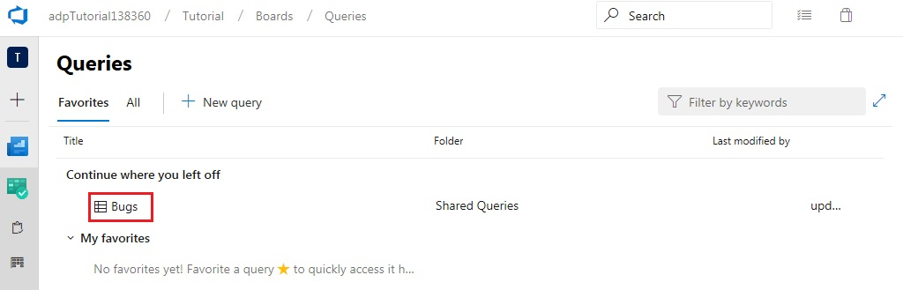

Close the bug and save the work item

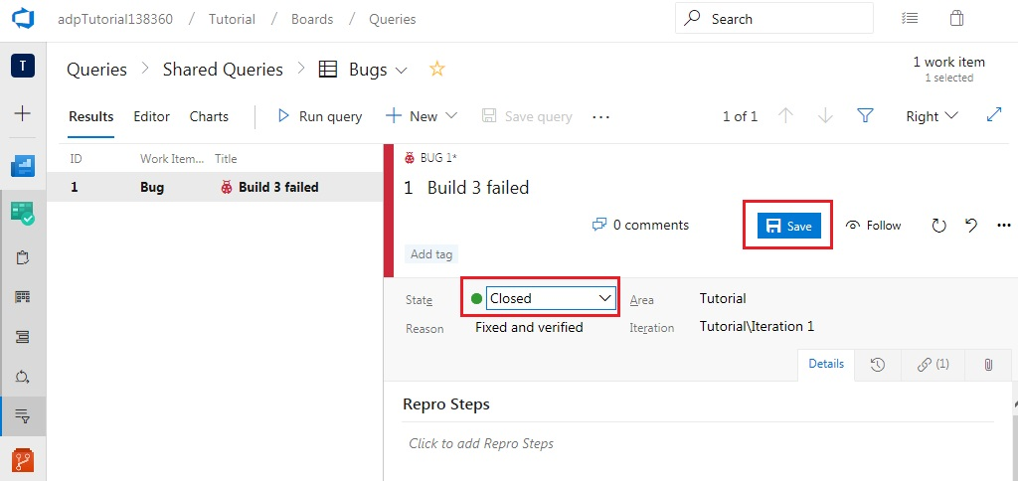

Now return to your release pipeline to view the logs of the local stage. This should now evaluate successfully with the approval pending. Click ‘Approve’.

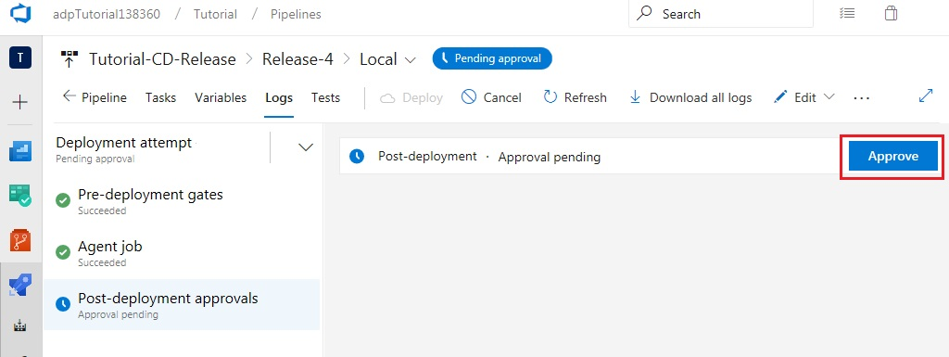

Enter an approval comment and then click ‘Approve’ again. Once this is done, the local stage of the release pipeline will Succeed.

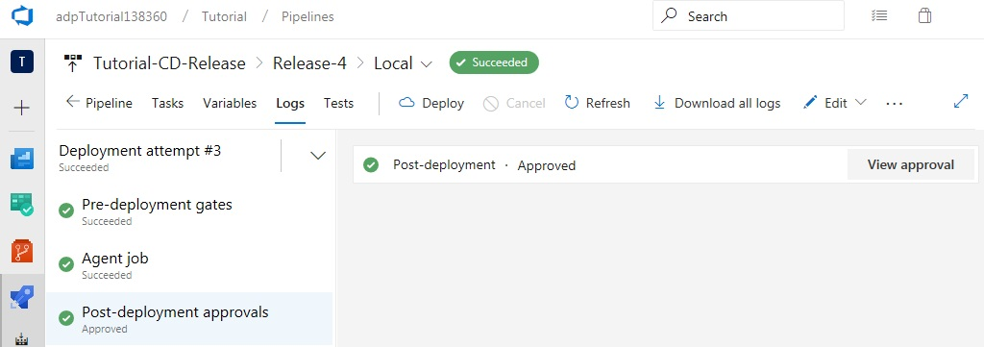

Return to the pipeline tab to see that the production stage has equally succeeded. Therefore, a new release will automatically be deployed to App Center as configured in previous sections. Take note of the pre-deployment and post-deployment conditions which have been met.

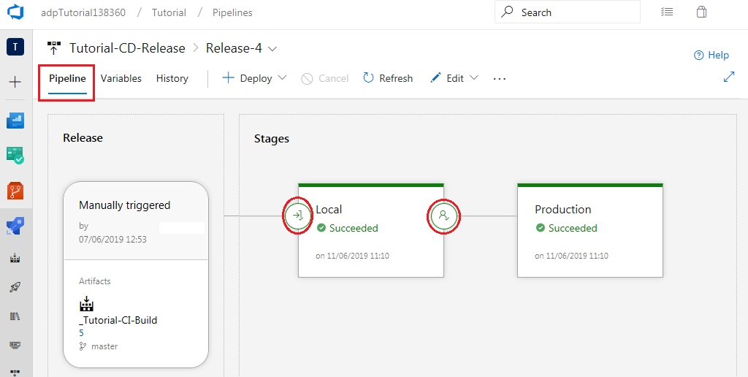

Unit tests and reports

Navigate to the builds tab, click edit and add the Visual Studio Test task from the ‘Test’ tab

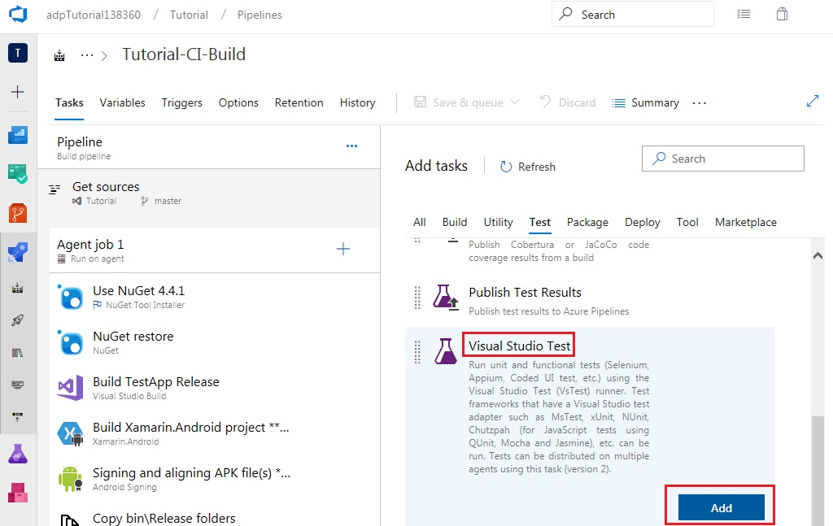

Move the Visual Studio Test task above the Xamarin.Android task and configure it as shown

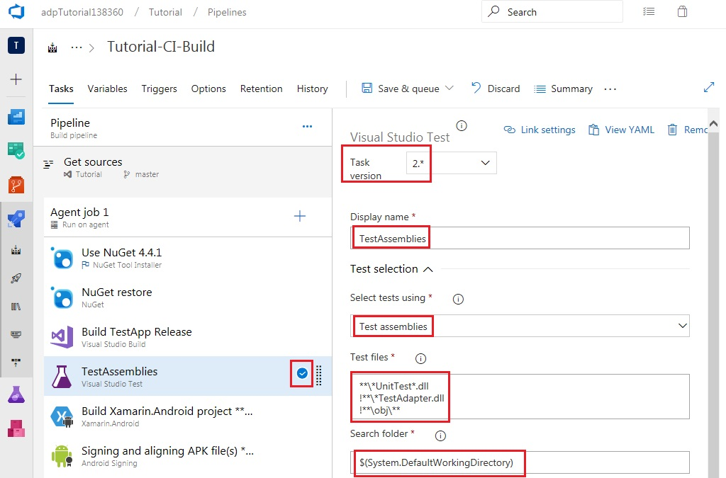

Configure execution options as follows

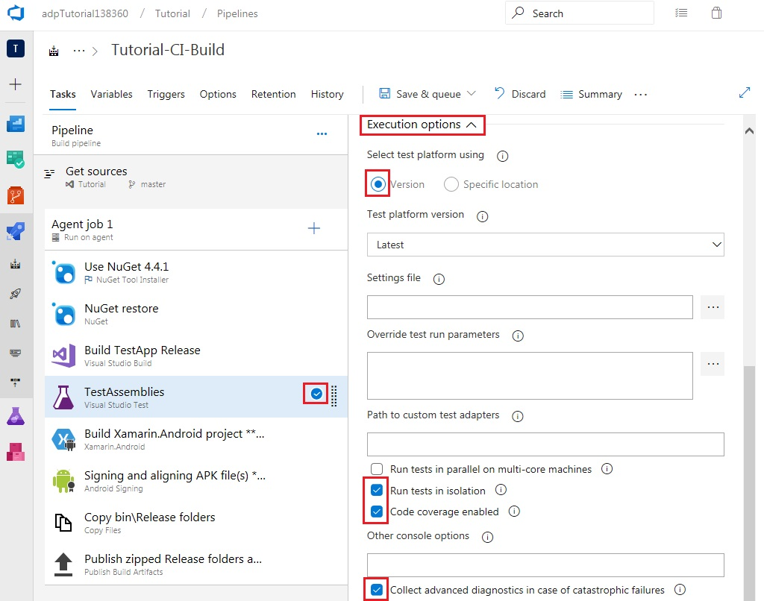

Save the changes without queueing

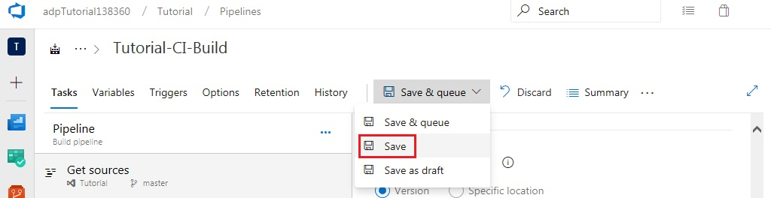

Return to Visual Studio to add some unit tests to the project. From the Solution Explorer window, add a new project to the TestApp solution.

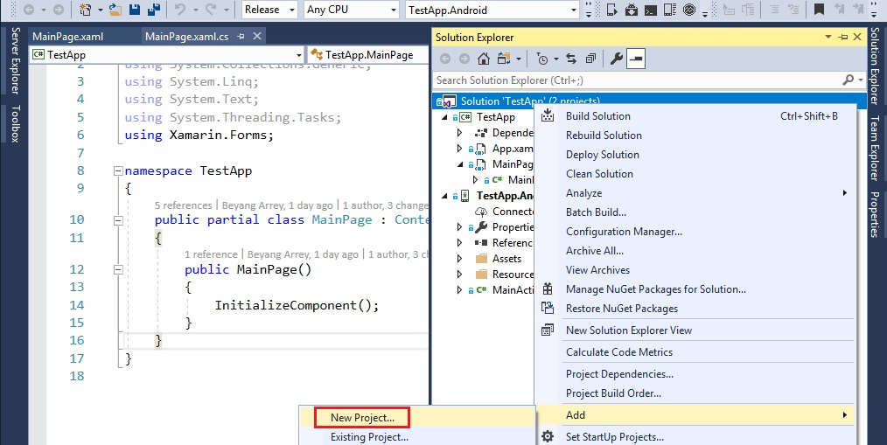

Configure the project as shown below, then click OK

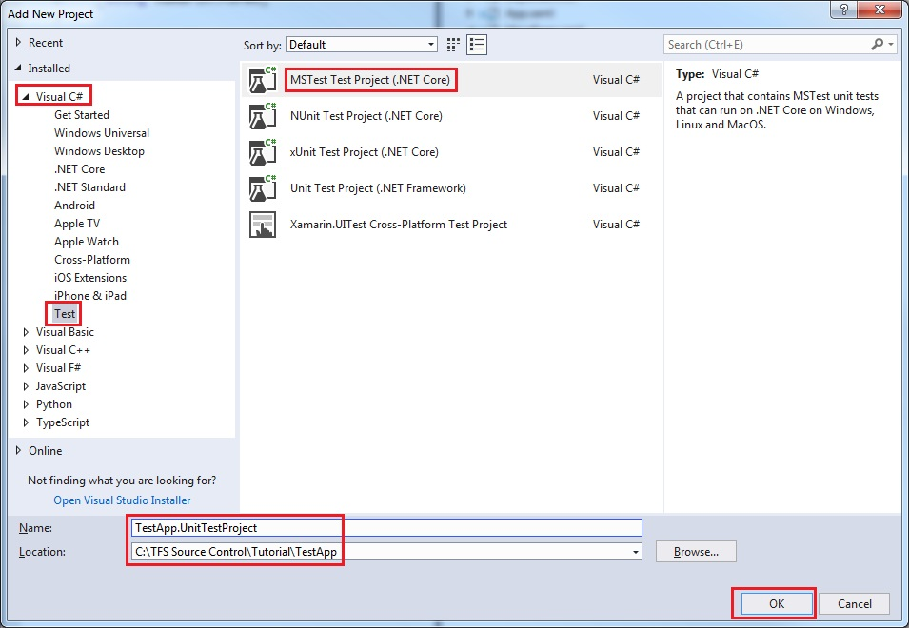

The project will be created with a file called UnitTest1.cs.

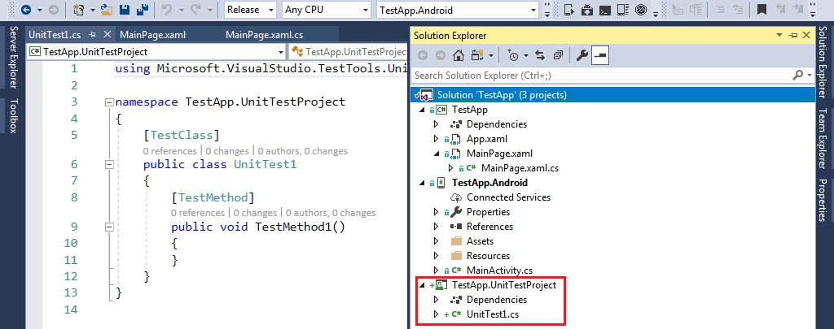

Edit this file as shown below and build the solution.

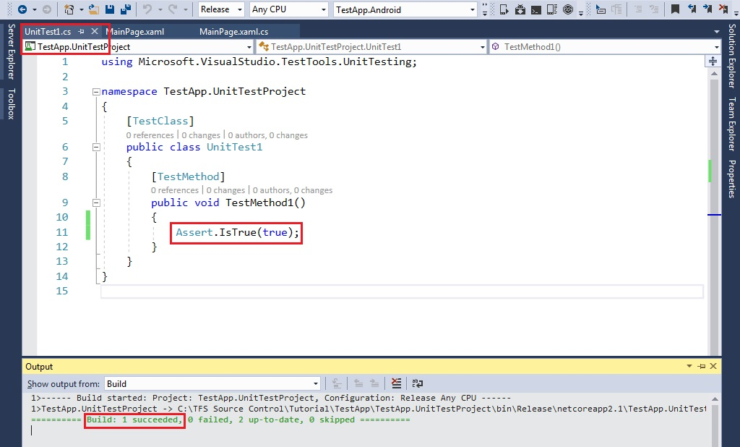

Now, open the Team Explorer window in Visual Studio and ignore the changes highlighted below. This will trigger an update to the ‘.gitignore’ file.

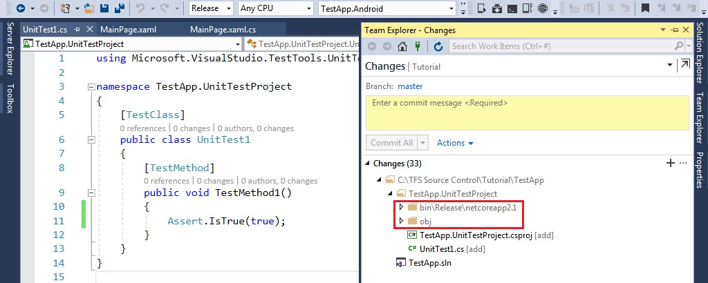

Add an appropriate comment and click Commit All. Click on the ‘Sync’ button under the ‘Home’ tab of the Team Explorer window in Visual Studio and ‘Push’ your commit to the server. Return to the builds pipeline and Click on the rolling build which was triggered by your code changes. Once the build completes, navigate to the tests tab to view the test report.

